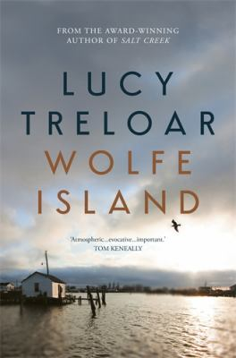
Wolfe Island by Lucy Treloar

Synopsis
Kitty Hawke, the last inhabitant of a dying island sinking into the wind-lashed Chesapeake Bay, has resigned herself to annihilation...
Until one night her granddaughter blows ashore in the midst of a storm, desperate, begging for sanctuary. For years, Kitty has kept herself to herself - with only the company of her wolfdog, Girl - unconcerned by the world outside, or perhaps avoiding its worst excesses. But blood cannot be turned away in times like these. And when trouble comes following her granddaughter, no one is more surprised than Kitty to find she will fight to save her as fiercely as her name suggests...

Discussion questions
- What did you think when Kitty stayed on Wolfe Island and didn’t return to the mainland?
- Despite her humorous name, Kitty Hawke is a formidable character. Kitty Hawke either directly or indirectly causes the death of four people yet we are still engaged to feel sympathetic towards her. Was this the case for you? Do you think she had good enough reasons for doing what she did?
- The mainland through which Kitty and her family travel is an anonymous country characterised by suspicion and threat. The family is threatened a number of times but there are also occasions where kindness is extended to them. Is this a reflection of the world today where strangers – or refugees – are treated with suspicion and fear?
- We first meet Alejandra when she is about seven years old. She returns to Wolfe Island ‘some years later’ as a young woman ‘and was exactly what she was going to become’. She says to Kitty that she will not waste this life. Does she represent a hope for the future and a vindication for Kitty for what she has endured and what she had to do to protect her family?
- Wolfe Island is told from Kitty’s point of view after the events of the novel are over. Do you think this method helps of hinders the storytelling in the novel?
- Wolfe Island seems set in a world which is uncertain and insecure. A world which is under threat even from the ocean which appears ready to swallow Wolfe Island at any time. In fact, water in all its forms – ocean, rain, snow, ice – is a constant factor in the novel. Is it correct to suggest that ‘water’ may be a metaphor for external threats to what seemed once to have been an idyllic life for Kitty Hawke?

Discussion questions from https://www.queenslandreviewerscollective.com/2019/09/25/an-interview-with-lucy-treloar-author-of-wolfe-island/

