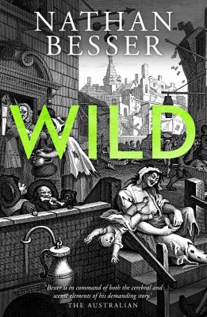
Wild by Nathan Besser

Synopsis
Jonathan Wild knows power like no one else in London. He arrived as a wide-eyed young man in 1703, dazzled by a metropolis brimming with trade, immigration and crime. With a combination of greed, arrogance and ambition, Wild stopped at nothing to secure his place in this great and monstrous London and within a few years, he became the city’s Thief-Taker General, one of the most feared and wealthy officials in town, charged with the capture and arrest of felons for reward. But his power is matched only by the number of enemies he’s made along the way, and his star is burning rather too brightly for the likings of some.
Daniel Defoe is in trouble. Following a series of failed business ventures, the renowned pamphleteer, fiction writer and political operative is dead broke. With his creditors at his heels, and facing debtors’ prison, Defoe is too crippled with anxiety to write. That is, until he visits Newgate Prison with the intention of chronicling the stories of its inmates, and meets a young man with a deep hatred for Jonathan Wild and a story to tell.

Discussion questions
- What's to like about Jonathan Wild? And what you do you perceive as his flaws?
- What's to like about Daniel Defoe? And what you do you perceive as his flaws
- What do you make of Jack Sheppard?
- The tale of Jonathan Wild has been told many times, including by John Gay in The Beggar’s Opera and Henry Fielding in Jonathan Wild. It exemplifies the British culture of enterprise, class and ruthlessness. Nathan Besser has created his own idiom for his version of this story. Did this language and fictional take, in concert, work for you?
- What other period books do you think use language as an effective scene-setting tool?
- How do you feel about the rewriting of history in contemporary novels?
- 'Some estimate the crowd at Jonathan Wild's execution in 1725 to have been 100,000. If true, this indicates that one in every six Londoners was present to witness his death' – James Byron. The career of Jonathan Wild, as told in Wild and other renditions, is perhaps the first detailed example of ‘organised crime’. From Al Capone to Bonny and Clyde and our own Ned Kelly, why do we continue to return to the stories of notorious criminals?
- Nathan Besser was steeped in his fascination of Jonathon’s Wild bold ambition and underhand business behaviours, trying to understand the motivations of a Georgian era bounty hunter. Then, in late 2015, Donald Trump announced his presidential aspirations, and the writing flowed. Here was a flamboyant, rebarbative entrepreneur. As much as politicians were lying to the people, people were lying to themselves. And in the midst of the chaos, if you were clever and despicable enough, you could get to the top. Has the world ever been thus?
- Who are the heroes of Wild?
Discussion questions from https://www.penguin.com.au/book-clubs/2351-wild-book-club-notes

