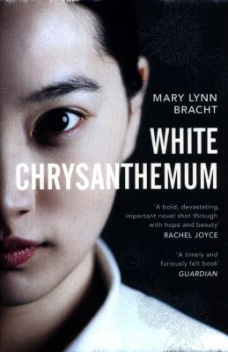
White Chrysanthemum by Mary Lynn Bracht

Synopsis
This is the story of Hana and her little sister Emi, who are part of an island community of haenyo, women who make their living from free diving off the southernmost tip of Korea. One day Hana sees a Japanese soldier heading for where Emi is guarding the day's catch on the beach. Saving her sister, Hana herself is captured and forced to become a "comfort woman" in a Japanese military brothel.
Moving between Hana in 1943 and Emi as an elderly woman today, White Chrysanthemum sheds light on a devastating history - and how the bond of sisterhood is strong enough to endure the evils of war.

Discussion questions
- Historical events, and war in particular, have always been fertile ground for fiction. What do you think this seam of truth adds to your reading of such novels, and this book in particular?
- What does being a haenyeo mean to Hana? How does this identity inspire her throughout the novel? Had you heard of the haenyeo before reading White Chrysanthemum?
- Were you surprised by the way the Japanese treated the Koreans during the Second World War? Has your understanding of the war changed after reading this novel?
- When we meet Emi, she often dreams of a girl swimming in the ocean. Why does Emi feel haunted by Hana? How does Emi remember her sister, and how does this relationship change throughout the novel?
- When the novel begins, Emi still lives on Jeju Island. What does Jeju Island mean for each sister? How would this story be different if it were set somewhere else?
- Is Keiko a friend to Hana? How does Hana’s time in the brothel alter her? How do the women she meets there support one another?
- How does Emi’s relationship with her son and daughter grow over the course of the novel? Why do you think she hasn’t told them about her family? Why do you think she changes her mind? Do you agree with her decision to tell them about her past?
- Everybody in the novel does bad things in one way or another, but what did you make of Marimoto as a character? Do you think he’s a dyed-in-the-wool villain, or do you think his experiences of war have made him the way he is?

Synopsis/Discussion questions from https://www.penguin.com.au/book-clubs/1791-white-chrysanthemum-book-club-notes

