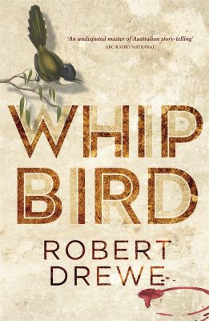
Whipbird by Robert Drewe

Synopsis
Kungadgee, Victoria, Australia. A weekend in late November, 2014. At Hugh and Christine Cleary’s new vineyard, Whipbird, six generations of the Cleary family are coming together from far and wide to celebrate the 160th anniversary of the arrival of their ancestor Conor Cleary from Ireland. Hugh has been meticulously planning the event for months – a chance to proudly showcase Whipbird to the extended clan. Some of these family members know each other; some don’t.
As the wine flows, it promises to be an eventful couple of days.

Discussion questions
- In Whipbird Robert Drewe brings us a masterful tragi-comedy of an Australian clan’s coming together. When the far-flung members of the Cleary family unite to celebrate their ancestry, all hell breaks loose. What unfolds is an Australian family saga as it’s never been told before, both hilarious and poignant. What would Conor Cleary make of his descendants?
- If Whipbird is about family, it is as much a portrait of a nation. What does Whipbird say about what it is to be Australian?
- Robert Drewe’s cast of characters in Whipbird has inspired one reviewer to applaud the book as ‘a kind of Canterbury Tales standing still’, alive with ockerish blarney. What character was most convincingly drawn for you?
- Once on the cusp of being an international rock star, Sly Cleary believes he is now in fact dead, while Conor Cleary – who is dead – is the omnipresent guest of honour. Discuss the two characters, and Drewe’s use of this device, and irony.
- During Hugh’s riotous ‘welcome’ speech, sister Thea – considered the family’s real success story – reflects that she finds Australian history unsatisfying because its central characters are unedifying, and its main events are inconclusive. Do you think Drewe shares this view?
- Hugh, Mick and Liam Cleary represent three generations of Cleary men, with support from cousins Ryan and Doug. How is masculinity explored in this novel?
- From the stalking ghost to Hugh’s welcome speech and the stolen Nolan, Drewe’s Whipbird is a comic feast. What made you laugh?
- In perhaps a poetic stroke of serendipity, the Richmond Football Club won the 2017 premiership the year Whipbird was published. What do the Tigers mean for Mick Cleary, the clan’s living patriarch?
- The novel opens and closes in flames. Discuss Whipbird’s masterful, epic ending.

Discussion questions from https://www.penguin.com.au/book-clubs/1785-whipbird-reading-group-notes

