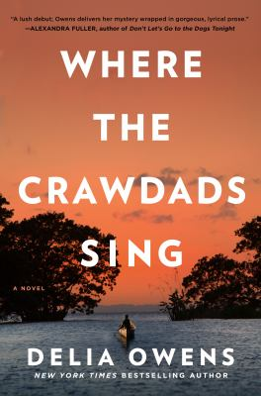
Where the Crawdads Sing by Delia Owens

Synopsis
For years, rumours of the ‘Marsh Girl’ have haunted Barkley Cove, a quiet town on the North Carolina coast. So in late 1969, when handsome Chase Andrews is found dead, the locals immediately suspect Kya Clark, the so-called Marsh Girl.
But Kya is not what they say. Sensitive and intelligent, she has survived for years alone in the marsh that she calls home, finding friends in the gulls and lessons in the sand.
Then the time comes when she yearns to be touched and loved. When two young men from town become intrigued by her wild beauty, Kya opens herself to a new life – until the unthinkable happens.

Discussion questions
- The North Carolina marsh where Kya lives has long been a sanctuary for outsiders. How does this setting shape the novel? How does growing up in this isolation affect Kya?
- Why does Kya choose not to go back to school? Do you think she makes the wrong decision? How does Kya’s lack of formal education shape her vision of the world?
- After Jodie and Pa leave Kya alone, she becomes close to Jumpin’ and Mabel. Why are these two adults drawn to Kya? What do they teach her about the world? Do you agree with Jumpin’s decision to protect Kya from social services (p. 110) and to encourage her to live alone in the marsh?
- Kya often watches the other young people from town— she even nicknames them “Tallskinnyblonde, Ponytailfreckleface, Shortblackhair, Alwayswearspearls, and Roundchubbycheeks” (p. 80). What does Kya learn from observing these girls? Why do you think she keeps her watching secret?
- Discuss Kya’s relationship with Tate. How does Tate’s understanding of Kya change over time? Is Tate a good partner for Kya? Why or why not?
- Tate’s father tells him that poems are important because “they make ya feel something” (p. 48). What does poetry mean to Tate? What does it mean to Kya? How does poetry help Kya throughout the novel?
- Kya watches the fireflies near her shack, and notices that the females can change their flashes to signal different things. What does this realization mean to Kya? What does it teach her about relationships? How does this lesson influence Kya’s decisions in the second half of the novel?
- Is Chase a different kind of man than Tate? How are they different? Is one man better? Do you think that their differences are biological or learned? How does Kya see each man?
- Were you surprised by the verdict in the Chase’s murder trial? What about by the ending of the novel? Do you agree with Tate’s final decision? Why or why not?

Synopsis/Discussion questions from https://www.littlebrown.co.uk/little-brown-news/2019/04/09/where-the-crawdads-sing-book-discussion-questions/

