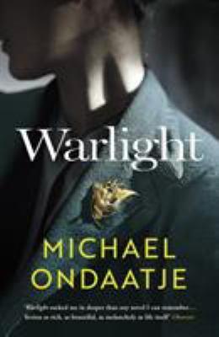
Warlight by Michael Ondaatje

Synopsis
In a narrative as beguiling and mysterious as memory itself—shadowed and luminous at once—we read the story of fourteen-year-old Nathaniel, and his older sister, Rachel.
In 1945, just after World War II, they stay behind in London when their parents move to Singapore, leaving them in the care of a mysterious figure named The Moth. They suspect he might be a criminal, and they grow both more convinced and less concerned as they come to know his eccentric crew of friends: men and women joined by a shared history of unspecified service during the war, all of whom seem, in some way, determined now to protect, and educate (in rather unusual ways) Rachel and Nathaniel.
But are they really what and who they claim to be? And what does it mean when the siblings' mother returns after months of silence without their father, explaining nothing, excusing nothing? A dozen years later, Nathaniel begins to uncover all that he didn't know and understand in that time, and it is this journey—through facts, recollection, and imagination—that he narrates in this masterwork from one of the great writers of our time.

Discussion questions
- One of the quandaries at the heart of Michael Ondaatje's novel is reconciling Rose Williams's bravery, indeed her patriotic heroism, and her treatment of Nathaniel and Rachel. How do readers, and especially her (fictional) children, wrap their heads around this inconsistency? How are we to consider Rose?
- What do you make of Moth and Darter? As Nathaniel, in the opening lines, puts it, "our parents left us in the care of two men who may have been criminals."
- Warlight's structure is anything but linear as it shifts back and forth in time and point of view. Is it confusing? Might the structure be a reflection of Nathaniel's own confusion: his sense of being able to see reality only dimly—as if through "warlight"?
- "The lost sequence in a life, they say, is the thing we always search out," Nathaniel tells us. How has that "lost sequence" of Nathaniel's life shaped who he is? When he and Rachel discover that the reason their mother gave for leaving them was not the true reason, how did her lie make them feel? What lasting repercussions does her untruthfulness leave?
- What does Nathaniel resolve within himself by the novel's end—what understanding has he come to? Or are things left unresolved for him—and for us? Is there a satisfactory resolution at the conclusion?

Discussion questions from https://www.litlovers.com/reading-guides/13-reading-guides/fiction/11276-warlight-ondaatje?showall=1

