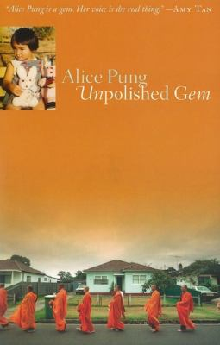
Unpolished Gem by Alice Pung

Synopsis
When Alice Pung’s family survives the killing fields of Cambodia and escapes the poverty of a Thai refugee camp, arriving in Australia with the clothes on their backs and little else, they think themselves blessed with good fortune. And they are—the Australian government provides them with housing and food, and soon Alice’s father finds a job that will support him, his mother, and his very pregnant wife. It is the 1980s, and little Alice is born into her family’s newfound luck and prosperity.
But economic and social prosperity come with a price—not one exacted by their new host, Australia, but one that they impose upon themselves. Adapting to life in this wealthy new land is more difficult than they imagine, as they learn to deal with displacement and life as outsiders, even in a community filled with fellow immigrants. Alice’s mother and her paternal grandmother face a special adversity—living with each other. And caught in the middle of it all is Alice, who realizes, perhaps better than anyone, the contradiction and complexity that come with living a dual life: the life of an Asian and the life of an Australian.

Discussion questions
- When Alice’s mother, father, aunt, and grandmother arrive in Australia, they are amazed by the shared wealth of its citizens and the generosity of the government when it comes to housing, feeding, and educating the fast-growing immigrant population. How does Pung convey the extent of her family’s first impression of Australia and, as her grandmother calls it, “Father Government”?
- As a result of her grandmother’s contentious relationship with her mother, Alice formed very different relationships with each woman. Compare and contrast Alice’s relationship with her grandmother to the dynamic that existed between Alice and her mother.
- Discuss the conflict that Alice feels throughout her primary and secondary school years—how she feels the desire to lead the “normal” life of an Australian child, but her family’s traditions, expectations, and economic and social situation prevent this from happening.
- How easy or difficult was it to understand Alice’s choice at the end of the book, when she breaks up with Michael? How great a toll would Alice have had to pay if she had continued dating him?
- Likewise, Alice’s program of study while at college and her career choice are dictated by her parents’ desires and expectations. Do you see any of her acquiescence as a survival tactic?
- The book’s epilogue takes place during the anniversary of her paternal grandmother’s passing. How is this a fitting capstone to Pung’s memoir? What aspects of the book does it highlight or signify, and what does it indicate about Alice’s future?
- Discuss the ways Pung combined humor with the more serious aspects of her story. Was her voice unique? At what points in the book was it most engaging?
- What does creative nonfiction offer us that other genres do not? How many memoirs have you read before this book, and how does this story compare with those others?
Synopsis/Discussion questions from https://www.penguinrandomhouse.com/books/303929/unpolished-gem-by-alice-pung/9780452290006/readers-guide/

