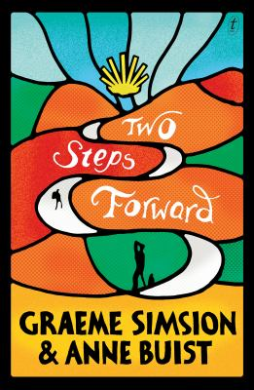
Two Steps Forward by Graeme Simsion & Anne Buist

Synopsis
The Camino de Santiago is the setting for an old fashioned pilgrimage and new-world self-discovery – plus a romance between two middle-aged walkers. Without their necessarily knowing it at first, the walk is a way for both Zoe and Martin – who set off independently from a small town in central France – to come to an understanding of themselves and their unresolved issues before they can ‘move on’.
Zoe has made a spur-of-the-moment decision to walk spurred on by an antique jewelled scallop shell. Martin is doing the Camino for pragmatic engineering and business reasons – to test a cart he has designed – although he acknowledges the personal challenges involved and is looking forward to time for reflection.
As Zoe walks, she works through her thoughts and emotions, first about her mother and the Catholic Church, then about her husband and his recent death, and then about what she did for her French friend Camille. Martin has been shaken up by his divorce. Nevertheless he too comes to understandings, mostly regarding his relationship with his daughter, but also about his ex-wife, and eventually himself

Discussion questions
- Discuss the two quotes chosen as epigraphs. How do they resonate with the novel? Is bravery required for departing without a destination? How do we know when it is time to leave, and what it is that we need to leave?
- Zoe is a lapsed Catholic, and her attitude to the church shifts through the novel. Do you think the book takes a position on formal religion as compared to a more general spirituality?
- Zoe and Martin set off with different purposes. How do their walks compare in the end? Discuss what they each realise, understand and learn about themselves.
- How or why does walking the Camino bring about self-knowledge and change? Does it inevitably do so? Towards the end of her walk, Zoe wonders what the point is: ‘If I’d stayed in LA and seen a therapist, I’d have worked through the same stuff’ (p. 299). Is she right?
- What do you think of the gender roles in the book – the female artist and the male engineer? Do you think Zoe and Martin are equally in touch with their emotions by the end of their story? Are their experiences on the Camino different because of their genders?
- Are we supposed to believe that the scallop charm has an influence on the wearer’s experience? Discuss other symbols in the novel (the goose outside the antique shop, for example, or the bell in Santiago). How do they work? How literally are we supposed to interpret them?
- Have you / would you walk the Camino or a similar pilgrimage path? Has the book inspired you to do so? What did / would you expect to get out of it

Synopsis & Discussion questions from https://www.textpublishing.com.au/books/two-steps-forward

