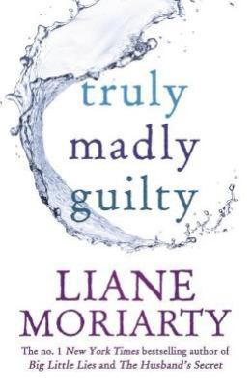
Truly Madly Guilty by Liane Moriarty

Synopsis
Clementine is haunted by regret. It was just a barbeque. They didn't even know their hosts that well, they were friends of friends. They could so easily have said no. But she and her husband Sam said yes, and now they can never change what they did and didn't do that Sunday afternoon.
Six responsible adults. Three cute kids. One playful dog. It's an ordinary weekend in the suburbs. What could possibly go wrong? Marriage, sex, parenthood and friendship: Liane Moriarty takes these elements of our lives and shows us how guilt can expose the fault lines in any relationship, and it is not until we appreciate the fragility of life that we can truly value what we have.

Discussion questions
- Discuss the novel’s title. Why do all of the characters feel so guilty? Should they? How do they deal with their guilt?
- What does Clementine mean when she thinks back on the “extraordinary ordinariness” of her life before the barbecue? How is the ordinary treated in this novel? Do you think it’s inevitable that we don’t appreciate the ordinary?
- Were you surprised that Erika and Oliver have a healthier sex life than Clementine and Sam? Discuss Clementine’s bleak view of marriage. What are the strengths and weaknesses of the three marriages in this novel?
- Discuss Clementine and Erika’s complicated friendship. Are the truest friendships the most difficult ones? Or would you say that Erika and Clementine are more like sisters, as Tiffany observes?
- What did you make of Erika’s request that Clementine donate her eggs? Were you surprised by Clementine’s response?
- In this novel, parenting is not always easy and wonderful. What do you think? How do the various mothers and fathers balance family and career?
- Money and class are knotty issues in this novel. Vid’s relationship with wealth seems to be very straightforward. Tiffany’s, though, is more complicated. Why do you think that is? What role do you think gender plays in this difference, if at all?
- Sylvia’s hoarding is a major source of embarrassment and sorrow for Erika. She reflects: “Her mother loved things so much that she had nothing.” What do you make of that line?
- Near the end of the novel, Clementine wonders “what sort of person Erika could have been, would have been, should have been, if she’d been given the privilege of an ordinary home. You could jump so much higher when you had somewhere safe to fall.” Do you agree? How are the various characters helped and hindered by their respective childhoods?
Synopsis/Discussion questions from https://www.panmacmillan.com.au/9781925481396/

