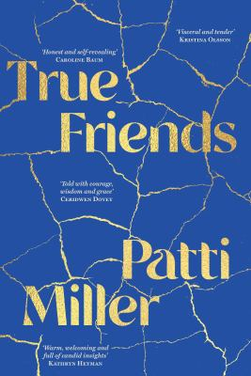
True Friends by Patti Miller

Synopsis
Friendships are among the most important relationships in our lives, often outlasting love affairs, marriages, even, at times, family connections. The loss of a friend can be one of life’s most disturbing events, yet these ‘friend break-ups’ are little acknowledged in our culture.
In True Friends, acclaimed author Patti Miller recounts the joyful making and then painful ending of a long, close friendship. It is a deep and influential relationship in her life, but when it inexplicably unravels, Patti is left searching for answers. As she tries to make sense of this ending, Patti considers other important friendships throughout her life, questioning who we are drawn to, what we really know of each other and why some friendships endure while others end.

Discussion questions
- The central story line of True Friends explores the friendship between Patti and Gina. Why do you think they first became friends? What is their friendship based on?
- Do you agree with Montaigne that friendship ‘must have no other traffic’ (pp. 145, 187, 241)? Do you think friendships should not include family?
- In True Friends, different friendships are explored from childhood through to the current era – do you recognise any of these friendships in your own life?
- ‘Given the gaps and errors in memory, even thus far, it seems necessary to say something about the way it creates stories about other people’ (p. 7). What importance do you think the nature and function of memory plays in this story? Does it add or detract from the book in your view?
- What is so significant about Patti’s friendship with Jane (pp. 63–108)? Have you had a friendship as influential as this?
- Why are excerpts and discussions about the oldest written story, The Epic of Gilgamesh, included? What do they add to the story of friendship?
- In an email to Patti, her friend Beth says: ‘With so few family, my friends have been my formation, identity and belonging, both men and women. But it is the women through my life who have shown me myself and abided. To them, the first tribute’ (p. 181). Do you think friendships between women are different from male friendships and friendships between men and women?
- Over the years there have been numerous stories, songs, poems and films that reflect on romance break-ups, but there are very few about friendship break-ups. Why do you think this is?
- Why do you think the friendship between Patti and Gina ended?
- Do authors have the right to ‘use’ their friends in their writing? Discuss.

Discussion questions from https://www.uqp.com.au/books/true-friends

