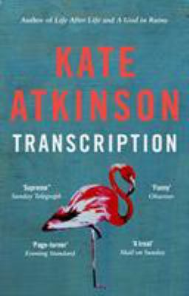
Transcription by Kate Atkinson

Synopsis
In 1940, eighteen-year old Juliet Armstrong is reluctantly recruited into the world of espionage. Sent to an obscure department of MI5 tasked with monitoring the comings and goings of British Fascist sympathizers, she discovers the work to be by turns both tedious and terrifying. But after the war has ended, she presumes the events of those years have been relegated to the past forever.
Ten years later, now a radio producer at the BBC, Juliet is unexpectedly confronted by figures from her past. A different war is being fought now, on a different battleground, but Juliet finds herself once more under threat. A bill of reckoning is due, and she finally begins to realize that there is no action without consequence.

Discussion questions
- The story starts off in 1981 and jumps back to 1940 and then moves to 1950 for a good chunk before finishing back in the ’80s. What did you think about this story structure and different time periods when it comes to story flow?
- Let’s evaluate Juliet in the time different time periods and how she grew and evolved. What surprised you the most about her?
- Let’s talk about Juliet’s dynamic with Perry. She obviously was in lust with him while he had other interests in mind, however, he still cared for her just not in the way she wanted. How did this showcase her naivety?
- And on the other hand, Juliet is very capable with her transcribing skills and is asked to go undercover. Why do you think Juliet was so skilled at being undercover?
- Now let’s focus on Godfrey, a complicated figure in many ways. He’s a spy but he seems fond of the British Fascist sympathizers, despite their beliefs. Why? What does that represent about human nature?
- When Juliet is in the 1950s, she’s working at the BBC. Why was this a logical transition for her?
- There’s a line toward the end when Mr ‘Fisher’ says “nothing is as simple as it looks.” What did that mean within the context of this book?
- What surprised you the most about the ending and the reveal of Juliet as a double agent?
- A key aspect of the book is about living with the choices we make. Once choice brings us down one road while the other one a different road. How does that relate to your own life?
Synopsis from https://www.littlebrown.com/titles/kate-atkinson/transcription/9780316479752/
Discussion questions from https://bookclubchat.com/books/book-club-questions-for-transcription-by-kate-atkinson/

