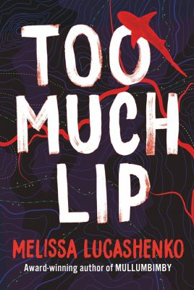
Too Much Lip by Melissa Lucashenko

Synopsis
In 1943, fourteen-year-old Owen Addison knew boxing was the only means of protection available for himself and his Aboriginal family in the era of forced assimilation. What happened to him next determined the course of not only his life but also that of his descendants. Decades later, Owen’s granddaughter Kerry Salter is angry with the world. Her girlfriend Allie – who’s been nabbed for an ill-conceived armed robbery – has recently broken up with her; Pop Owen is dying so she has to head home to small-town Durrongo to say her goodbyes.
Meanwhile, ambitious southern realtor Martina Rossi has been asked to manage Buckley’s real estate agency at Patterson, the nearest town to Durrongo. Her task is to help shady local mayor, Jim Buckley shift some properties, making way for a prison development on the riverbank of the Salter family’s traditional lands, threatening Granny Ava’s Island. Scarred by a lifetime of racism, Kerry has contempt for most dugais or ‘whitenormalsavages’ and has never contemplated dating one until she meets the handsome gym owner Steve Abarco. But when Kerry accidentally discovers that Martina is her long-lost sister Donna, she isn’t sure how to break the news to the family. Will the Salters be able to stop the sale of their precious homeland?

Discussion questions
- Why is Kerry so angry with the world, and why do her family give her such a hard time?
- Kenny is always after ‘the main chance’. Kerry observes wryly of him at one point: ‘Action was his new catchcry; Ken’s self-image had shifted from Retired-Footy-Hero-cum-Sex-God to Activist and Culture Man. So far his activism had consisted of vague threats of revolution down the pub, and of dragging an ancient land rights shirt from the bottom of the hall cupboard.’ (p. 98) Does he have any redeeming features? In the context of Durrongo, what does Kenny’s presence offer the family home?
- The novel deals with both environmental despoilment through development and the destruction of Aboriginal sacred places. Mayor Jim Buckley plans to sell the land around Ava’s Island so a prison can be built on it. Is his corrupt behaviour atypical, or is this part of a larger problem?
- Why is the role of female elders such as Pretty Mary, Granny Ruth and Granny Ava so important in Kerry’s family?
- Kerry reflects on how Aboriginal kids like Brandon are treated by the law: ‘But that was dugai logic for ya. Steal a million acres and you’re a pioneer hero with a brass statue in the council chambers, but pinch a car or a mobile phone and you’re some kind of fucking monster.’ (p. 173) Do you agree with her assertion?
- Having discovered how badly Pop suffered as a youth, is it possible to have empathy towards him? Can intergenerational violence and abuse ever be excused?
- Why did Donna stay away for so long, what did it cost her to do so, and what did she gain from being estranged from her family?
Synopsis/Discussion questions from https://www.uqp.com.au/books/too-much-lip

