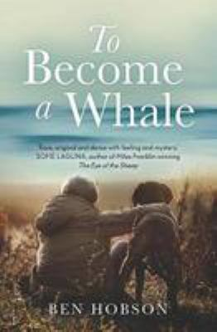
To Become a Whale by Ben Hobson

Synopsis
To Become a Whale tells the story of 13-year-old Sam Keogh, whose mother has died. Sam has to learn how to live with his silent, hitherto absent father, who decides to make a man out of his son by taking him to work at Tangalooma, then the largest whaling station in the southern hemisphere.
What follows is the devastatingly beautiful story of a gentle boy trying to make sense of the terrible reality of whaling and the cruelty and alienation of his new world, the world of men.

Discussion questions
- Why do you think the author mostly refers to Sam and Walter as ‘the boy’ and ‘the father’ throughout the book? What effect does it have?
- There are many instances throughout the novel where male characters communicate without speaking. Do you think men are more likely to have shared understandings that don’t need to be verbalised?
- “It just seems when I’m not there I’m not really in my life, you know?” (p.99). Why do you think Walter feels more at home on the whaling station?
- How does Walter’s approach to training Albert the puppy reflect his understanding of parenting? Do you think Sam’s father is trying to be a good parent? Is he?
- When Sam neglects to sift the sand before mixing cement, his father says he should know how to do it as ‘it’s common bloody sense’ (p. 73). Is it? Is this a reflection of Sam’s limitations or Walter’s?
- Do you think either Sam or Walter effectively express their grief for Elizabeth?
- “I used to be like you but Papa knocked it out of me early on. Bit hard on a farm if you’ve got a kid worrying about the cows you have to send off to the abattoir. So he taught me to grow up about it, be a man” (p. 196). Do you think that the idea of being a man has changed since the 1960s?
- When Sam visualises hurting his puppy Albert (p.276), is this a sign of his emerging masculinity or just a reflection of his experiences? What impact do you think Sam’s time at Tangalooma has on him?
- When Sam expresses his dislike of the whaling industry, his father asks him how it is any different from the meat industry and killing a cow. Do you think there is a difference?
- Do you think the novel accurately captures the experience of adolescence? If so, in what ways?

Synopsis/Discussion questions from https://www.allenandunwin.com/browse/book/Ben-Hobson-To-Become-a-Whale-9781760294397

