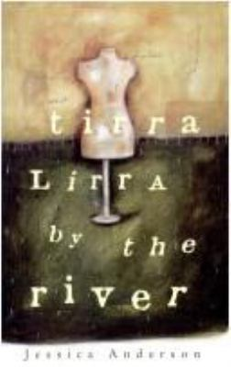
Tirra Lirra By the River by Jessica Anderson

Synopsis
A moving account of one woman’s remarkable life. The story is centered around the selective memories of Nora Porteous, a woman in the later part of her life, who returns to Queensland after a very long time, and the people and events of her past are not like she remembered them. Hence her memories spin out of control and reveal hidden events of her long life. The text is written without chapters, but it is obviously made up of 3 acts of Nora’s life: her childhood and early marriage; her life as a single woman and dressmaker in London; and her old age in Queensland, which the novel leaves unresolved.
The themes within this text are: quest for independence; relationships between men and women; search for connection, loss of innocence, the importance of self-knowledge; and, the nature of memory. These numerous and interwoven subjects and themes reach a crescendo at the end when Nora finally remembers something about her late father and his funeral.

Discussion questions
- Discuss the importance of self-knowledge, or the lack of, within this text.
- What impact does Ida Mayo’s death have on Nora?
- What impact does the end of the mail strike have for Nora?
- What is the significance of paintings in the novel?
- Discuss the fates of the male characters against those of the female characters.
- What conclusions can we draw about the role of women at the time of the novel?
- The text is centered around the intermittent and free-falling memories of Nora. Discuss the nature of memory.

