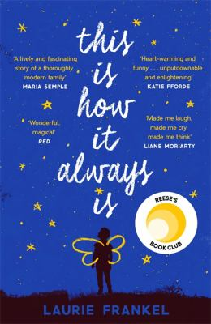
This is How it Always is by Laurie Frankel

Synopsis
When Rosie and Penn and their four boys welcome the newest member of their family, no one is surprised it’s another baby boy. But at least their large, loving, chaotic family knows what to expect. But Claude is not like his brothers. One day he puts on a dress and refuses to take it off. He wants to bring a purse to kindergarten. He wants hair long enough to sit on. When he grows up, Claude says, he wants to be a girl.
Rosie and Penn aren’t panicked at first. Kids go through phases, after all, and make-believe is fun. But soon the entire family is keeping Claude’s secret. Until one day it explodes.
This Is How It Always Is is a novel about revelations, transformations, fairy tales, and family. And it’s about the ways this is how it always is: Change is always hard and miraculous and hard again; parenting is always a leap into the unknown with crossed fingers and full hearts; children grow but not always according to plan. And families with secrets don’t get to keep them forever.

Discussion questions
- How do the epigraphs help prepare the reader for the many crossroads the WalshAdams family will have to face? What about the first word of the novel, “but”?
- In what ways does the book tackle typical definitions of boys and girls, men and women? Did it change your view of gender and identity as you read?
- When Rosie first takes Poppy on playdates with other girls, the moms begin telling her how brave she is. “Rosie appreciated the support but wasn’t sure parenting ever really qualified as brave—or maybe it always did—because it’s not like you had a choice.” How are each of the characters brave? Discuss how (or if) parenting requires acts of bravery.
- After Jane Doe’s trauma, Rosie thinks, “Head colds should be tolerated. Children should be celebrated.” What is the difference between tolerance and acceptance? Acceptance and celebration? Discuss how language, down to the pronouns we use, affects the way we interact with people different from ourselves.
- When Rosie and Penn discuss what course Poppy should take before puberty, Rosie says: “When a little girl wants to wear jeans and play soccer, her parents are thrilled, but when a little boy wants to wear a dress and play dolls, his parents send him to therapy and enroll him in a study.” Are young boys more constrained by gender stereotypes than young girls? Does the weight of gendered expectations shift from one gender to another as we grow up? If so, when?
- In the penultimate, fairy tale chapter, the witch tells Grumwald that he must share his story, that “story is the best magic there is.” What is the importance of sharing stories? Do secrets have their place as well, or do you agree that “secrets make everyone alone”?
- When comforting Poppy, Ben says, “Fitting in and being normal doesn’t exist.” How does the novel continuously challenge the idea of “normal”?
Synopsis / Discussion questions from https://www.lauriefrankel.net/this-is-how-it-always-is-book-club-guide.html

