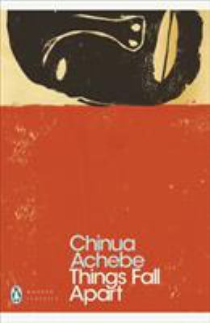
Things Fall Apart by Chinua Achebe

Synopsis
The novel chronicles the life of Okonkwo, the leader of an Igbo community, from the events leading up to his banishment from the community for accidentally killing a clansman, through the seven years of his exile, to his return, and it addresses a particular problem of emergent Africa—the intrusion in the 1890s of white missionaries and colonial government into tribal Igbo society.
Traditionally structured, and peppered with Igbo proverbs, it describes the simultaneous disintegration of its protagonist Okonkwo and of his village.

Discussion questions
- The text includes many original African terms and there is a glossary provided. Do you find that this lends atmospheric authenticity, thus bringing you closer to the work? Do you find it helpful?
- There is an issue here of fate versus personal control over destiny. For example, Okonkwo’s father is sometimes held responsible for his own actions, while at other times he is referred to as ill-fated and a victim of evil-fortune. Which do you think Okonkwo believes is true?
- Our own news media pre-programs us to view the kind of culture clash represented here as being purely racial in basis. Does Achebe’s work impress as being primarily concerned with black versus white tensions? If not, what else is going on here?
- Nature plays an integral role in the mythic and real life of the Ibo villagers, much more so than in our own society. Discuss ways in which their perception of animals–such as the cat, the locust, the python–differ from your own, and how these different beliefs shape our behavior.
- Of one of the goddesses, it is said: "It was not the same Chielo who sat with her in the market…Chielo was not a woman that night" (p. 106). What do you make of this culture where people can be both themselves and also assume other personas? Can you think of any parallels in your own world?
- While the traditional figure of Okonkwo can in no doubt be seen as the central figure in the tale, Achebe chooses to relate his story in the third person rather than the first person narrative style. What benefits does he reap by adopting this approach?
- The title of the novel is derived from the William Butler Yeats poem entitled The Second Coming, concerned with the second coming of Christ. The completed line reads: "Things fall apart; the centre cannot hold." What layers of meaning are discernible when this completed line is applied to the story?
- The District Commissioner is going to title his work The Pacification of the Primitive Tribes of the Niger (p. 209). What do you interpret from this to be his perception of Okonkwo and the people of Umuofia? And what do you imagine this augurs in the ensuing volumes in Achebe’s trilogy of Nigerian life?
Discussion questions from https://www.penguinrandomhouse.com/books/565351/things-fall-apart-by-chinua-achebe/readers-guide/

