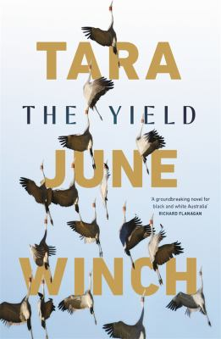
The Yield by Tara Winch

Synopsis
Knowing that he will soon die, Albert ‘Poppy’ Gondiwindi takes pen to paper. His life has been spent on the banks of the Murrumby River at Prosperous House, on Massacre Plains. Albert is determined to pass on the language of his people and everything that was ever remembered. He finds the words on the wind.
August Gondiwindi has been living on the other side of the world for ten years when she learns of her grandfather’s death. She returns home for his burial, wracked with grief and burdened with all she tried to leave behind. Her homecoming is bittersweet as she confronts the love of her kin and news that Prosperous is to be repossessed by a mining company.
Determined to make amends she endeavours to save their land – a quest that leads her to the voice of her grandfather and into the past, the stories of her people, the secrets of the river.

Discussion questions
- Tara June Winch chose to give voices to August, Albert Goondiwindi and Ferdinand Greenleaf. Why do you think she chose the split narrative? What is the impact of using such diverse voices and experiences?
- Poppy says, 'Nothing ever really dies.’ In what way is this idea supported in The Yield? What impact do those who are no longer alive still have on family and community?
- August Goondiwindi left Prosperous a long time ago but has never felt quite whole. Once back, August finds that she desperately wants to be home. What does Prosperous now offer her that it didn’t provide years ago? What are the fundamental elements of ‘home’?
- Poppy says 'just tell the truth and someone will hear it eventually'. Is it important for everybody’s stories to be told? What are the dangers in silencing some people’s stories?
- Language is a powerful tool that can place and displace people, empower or take control away. August says every family has its own special language. How can families be seen to have their own language? How does this help to shape families? Why might it cause difficulties for people outside of the family?
- After they discover his letters, August defends Greenleaf’s actions saying that he believed that what he was doing was right and he regretted the outcome. Aunt Missy tells her that he only regretted it when it negatively affected him. Which perspective do you agree with?
- How did you feel about Poppy’s method of bringing Wiradjuri language back through stories?
- How do you interpret the title of the novel?
Synopsis/Discussion questions from https://www.penguin.com.au/book-clubs/2284-the-yield-book-club-notes#:~:text=The%20Yield%3A%20Winner%20of%20the,Shortlisted%20for%20the%20Stella%20Prize.

