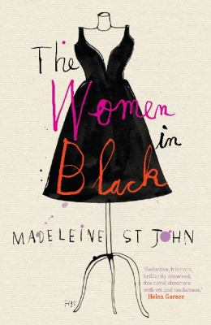
The Women in Black by Madeleine St John

Synopsis
The women in black, so named for the black frocks they wear while working at Goode’s department store, are busy selling ladies’ dresses during the holiday rush. But they somehow find time to pursue other goals…
Patty, in her mid-thirties, has been working at Goode’s for years. Her husband, Frank, eats a steak for dinner every night, watches a few minutes of TV, and then turns in. Patty yearns for a baby, but Frank is always too tired for that kind of thing. Sweet, unlucky Fay wants to settle down with a nice man, but somehow nice men don’t see her as marriage material. Glamorous Magda runs the high-end gowns department. A Slovenian émigré, Magda is cultured and continental and hopes to open her own boutique one day. Lisa, a clever and shy teenager, takes a job at Goode’s during her school break. Lisa wants to go to university and dreams of becoming a poet, but her father objects to both notions.
By the time the last marked-down dress is sold, all of their lives will be forever changed.

Discussion questions
- The Women in Black has been described by critics and readers alike as hilarious and a comic masterpiece. What are some of the funniest moments in the text?
- The Women in Black is set against the backdrop of great societal change in 1950s Australia—from evolving roles for women to an influx of postwar European refugees. How does St John use her characters to illustrate these changes?
- Compare Patty’s marriage to Frank with Magda’s marriage to Stefan. Other than the fact that neither couple has children, how are these relationships similar?
- Fay Baines lives by the motto “If at first you don’t succeed, try, try, try again” (page 15). In the realm of romance, this motto doesn’t work for her (until it does). Fay does not have family around to offer emotional support during her unhappy times. What advice would you offer Fay?
- Nearly all of the details of Miss Jacobs’s life remain a secret, even her name. What do you think she is supposed to represent? Who do you imagine she is mailing letters to on Christmas Eve when Mr. Ryder spots her (page 121)?
- Both Stefan and Rudi stand in stark contrast to the Australian men in the novel. Discuss the ways in which the Australian men are as trapped as the women. Do any of the men in the book defy the roles set for them?
- When Lisa falls in love with one of Magda’s model gowns, she is hit by “the sudden recognition that a particular frock is not merely pretty, would not merely suit one, but answers beyond these necessary attributes to one’s deepest notion of oneself” (page 65). Have you had a similar feeling about an item of clothing before? Discuss.
- “Change is the law of life,” remarks Mr. Ryder in the closing pages of the book (page 208). What do you imagine Lisa, Magda, Fay, and Patty will be doing the following Christmas?
Synopsis/Discussion questions from https://www.simonandschuster.com/books/The-Women-in-Black/Madeleine-St-John/9781982134082

