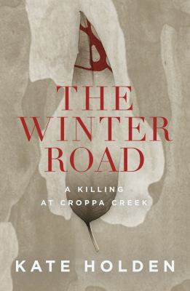
The Winter Road by Kate Holden

Synopsis
July 2014, a lonely road at twilight outside Croppa Creek, New South Wales: 80-year-old farmer Ian Turnbull takes out a .22 and shoots environmental officer Glen Turner in the back. On one side, a farmer hoping to secure his family’s wealth on the richest agricultural soil in the country. On the other, his obsession: the government man trying to apply environmental laws.
The brutal killing of Glen Turner splits open the story of our place on this land. Is our time on this soil a tale of tragedy or triumph – are we reaping what we’ve sown? Do we owe protection to the land, or does it owe us a living? And what happens when, in pursuit of an inheritance for his family, a man creates terrible consequences?

Discussion questions
- In chapter one we are given a brief history of the land – its settlement, the dispossession of its indigenous owners, and the development of the agricultural lands. How does this frame the story we are about to read?
- Were you familiar with the case before reading the book? Was your idea of Turnbull and his situation, or Turner and his work, different before reading the book?
- In one of their interactions, Turnbull says to Turner, ‘I had to pay the government a quarter of a million dollars in taxes, and you come here to tell me what I can and can’t do.’ (p. 47) Discuss this statement and how it relates to landowners generally, and the sentiment of property developers.
- The historical murders of First Nations peoples are noted throughout the book. How does the Myall Creek Massacre (and the community response to it in the years since) relate to the conservation of the native land, and indeed the murder of Turner?
- Environmental crime has traditionally been seen as victimless. How are public attitudes changing toward this?
- Turnbull told his son Roger that he had dug graves for Turner and a colleague. Why do you think the warning signs were ignored?
- How was Turnbull portrayed by the media? How did the community respond to his incarceration? Why do you think the farming community supported him?
- A recurring theme throughout the book is loss. This includes loss of land, life, family, habitat, wellbeing, future and past. Discuss how the theme threads throughout the book.
- Has the murder of Glen Turner had an effect on environmental protection law and conservation activism?

Synopsis/Discussion questions from https://www.blackincbooks.com.au/books/winter-road

