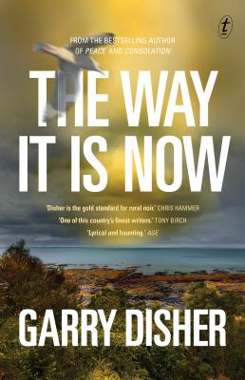
The Way it is Now by Garry Disher

Synopsis
Twenty years ago Charlie Deravin’s mother went missing near the family beach shack—believed murdered; body never found. His father has lived under a cloud of suspicion ever since.
Now Charlie’s back living in the shack in Menlo Beach, on disciplinary leave from his job with the police sex-crimes unit, and permanent leave from his marriage. After two decades worrying away at the mystery of his mother’s disappearance, he’s run out of leads.
Then the skeletal remains of two people are found in the excavation of a new building site—and the past comes crashing in on Charlie.
The Way It Is Now is the enthralling new novel from Garry Disher, one of Australia’s most loved and celebrated crime writers.

Discussion questions
- The trope of the ‘Dead Girl’ in crime fiction is the subject of much criticism and debate, primarily because this phenomenon strips female characters of their agency and identity. How does Disher use the novel’s extended prologue to resist this trope?
- Do you suspect, at first, that Billy Saul’s disappearance is connected to the disappearance of Charlie’s mum?
- ‘That’s how it had always been. Mark Valente the alpha figure, the ultimate father of all those cops’ kids back when Charlie was little, kicking a ball around. Throwing, catching, batting, running… Toeing the line’ (p55). Discuss Valente’s subtle dominance in the book. Does his ongoing presence make you suspect him of anything, or do you just write him off as being from a particular time?
- How does the book’s title, The Way It Is Now, speak to the way that Disher explores themes of masculinity and male violence against women?
- How does Charlie experience fear differently to the women in the book, for example Karen Wagoner’s fear of ‘the Menlo Beach cop mafia’ (p110)? Do you think he’s aware of the difference?
- Discuss the differences in the relationship that Liam and Charlie each have with their father. If you imagine the book’s narrative into the future, how do you think Liam’s attitude towards his father will have shifted upon learning the truth (if at all)?
- Charlie accuses Allardyce of doing a poor investigation on the Kessler case, saying ‘everyone went straight down the victim-blaming route, including you. Tunnel vision. You practically told us not to look too hard’ (p263). Is his accusation a fair assessment of the judicial and cultural responses to rape more broadly?
Discussion questions from https://www.textpublishing.com.au/books/the-way-it-is-now

