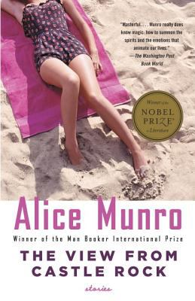

The View from Castle Rock by Alice Munro

Synopsis
In her most personal collection to date, Alice Munro has created stories based on her own past as well as by elaborating on the traces—letters, records, tombstones—left behind by her ancestors from Scotland who sailed for Canada in 1818.

Discussion questions
“The View from Castle Rock”
- Though Walter refuses Nettie’s father’s offer of work and in doing so refuses to commit himself to Nettie, in later life “he will find that she is a source of happiness, available to him till the day he dies.” Such foolish thoughts as a man may have in secret” [p. 78]. Why does Walter pass up this offer?
- James Laidlaw has wanted all his life to go to America with his family [p. 62]; why, once he is on the ship, does he lose interest?
“Working for a Living”
- In what details does this story show how life’s economic difficulties diminish people? Does the father seem somehow heroic in the face of his disappointments? What becomes of the mother’s early entrepreneurial talents?
“Home”
- When her father says, “I know how you loved this place,” the daughter thinks , “And I don’t tell him that I am not sure now whether I love any place, and that it seems to me it was myself that I loved here” [p. 290]. How has the daughter’s self-love helped her to escape from the life she might have had, had she stayed close to home?
“Messenger”
- Munro writes in her epilogue, “We can’t resist this rifling around in the past, sifting the untrustworthy evidence, linking stray names and questionable dates and anecdotes together, hanging on to threads, insisting on being joined to dead people and therefore to life” [p. 347]. What is the overall effect of these stories, and how do they make you think about your own family’s history and your place in it?
On The View from Castle Rock
- Discuss Munro’s decision to create a collection of stories from her own and her family’s history. She writes in her foreword, “These are stories. You could say that such stories pay more attention to the truth of a life than fiction usually does. But not enough to swear on. The part of this book that might be called family history has expanded into fiction, but always within the outline of a true narrative”. How and why is this approach interesting??
Discussion questions from https://www.penguinrandomhouse.com/books/118624/the-view-from-castle-rock-by-alice-munro/9781400077922/readers-guide/

