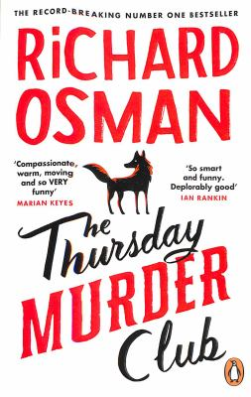
The Thursday Murder Club by Richard Osman

Synopsis
Every Thursday, four unlikely friends meet in the Jigsaw Room at the luxurious Coopers Chase Retirement Village to solve cold cases that have been languishing on the books for years. There’s Red Ron, the infamous former socialist firebrand, still causing trouble wherever he can; gentle Joyce, widowed, pining for another resident, but surely not as innocent as she seems; Ibrahim, a former therapist who understands the darker side of human nature; and Elizabeth? Well, no one is quite sure who she really is, but she’s definitely not a woman to underestimate.
Though they may be in their seventies, Elizabeth, Ibrahim, Joyce, and Ron still have a few tricks up their sleeves. When a local property developer winds up dead, The Thursday Murder Club finds themselves in the middle of their first live case—can the four catch the killer before it’s too late?

Discussion questions
- Though the book follows the four friends—Joyce, Elizabeth, Ibrahim, and Ron—solving the murder, the only first-person POV is Joyce’s via her diary. Why do you think the author chose to show her perspective in such a way?
- Joyce was a nurse, Elizabeth was in the secret service, Ibrahim was a psychiatrist, and Ron was a trade union leader. Who do you think was most helpful in solving the crime? What strengths did they each bring to the table? What were their weaknesses?
- Society often writes off the abilities of the elderly—assuming both body and mind are deteriorating. At the heart of The Thursday Murder Club is a lesson to never to underestimate this population. Who misjudges the residents of Coopers Chase the most? What are the consequences of underestimating the four friends?
- One of the reoccurring themes is the gray area between the law and each character’s moral code. Do you think Penny’s husband, John, did the right thing? How about Penny?
- At any point, did you have an idea of who might have committed the murder? Who did you suspect, and why? Were you correct?
- Joyce is always baking, and the others are always eating. The next question is simple: What is the best cake?
- If you had to solve a murder, which three people—could be friends, family, celebrities—would you choose to help you solve it?
Synopsis/Questions from https://www.penguin.com.au/book-clubs/2934-thursday-murder-club-book-club-notes

