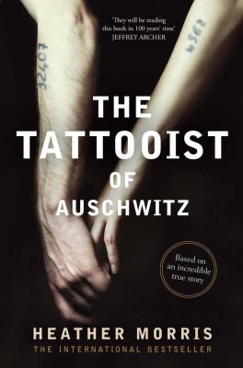
The Tattooist of Auschwitz by Heather Morris

Synopsis
In April 1942, Lale Sokolov, a Slovakian Jew, is forcibly transported to the concentration camps at Auschwitz-Birkenau.
When his captors discover that he speaks several languages, he is put to work as a Tatowierer (the German word for tattooist), tasked with permanently marking his fellow prisoners.
Imprisoned for over two and a half years, Lale witnesses horrific atrocities and barbarism—but also incredible acts of bravery and compassion. Risking his own life, he uses his privileged position to exchange jewels and money from murdered Jews for food to keep his fellow prisoners alive.
One day in July 1942, Lale, prisoner 32407, comforts a trembling young woman waiting in line to have the number 34902 tattooed onto her arm. Her name is Gita, and in that first encounter, Lale vows to somehow survive the camp and marry her.

Discussion questions
- How did you feel about Lale when he was first introduced, as he arrived in Auschwitz? How did your understanding of him change throughout the novel?
- What qualities did Lale have that influenced the way he was treated in the camp? Where did those qualities come from?
- Survival in the camp depended on people doing deeds of questionable morality. Lale became the tattooist, but how did Gita’s choices affect her survival? What about her friend who befriended a Nazi?
- Inmates in the concentration camp had to make life-or-death decisions every day. Why did some make the “right” decisions and survive while others did not?
- The Tattooist of Auschwitz makes clear that there were also non-Jewish prisoners in the camp. How did the treatment of Jews differ from that of non-Jews? How did differences manifest themselves?
- Had Gita and Lale met in a more conventional way, would they have developed the same kind of relationship? How did their circumstances change the course of their romance?
- In what ways was Lale a hero? In what ways was he an ordinary man?
- Lale faced danger even after the camp was liberated. How did his experiences immediately after liberation prepare him for the rest of his life?
- How does The Tattooist of Auschwitz change your perceptions about the Holocaust in particular, and war in general? What implications does this book hold for our own time?
Synopsis/Discussion questions from https://www.harpercollins.com/products/the-tattooist-of-auschwitz-heather-morris?variant=32130278228002

