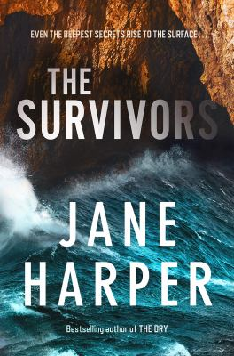
The Survivors by Jane Harper

Synopsis
Kieran Elliott returns to his childhood home with his girlfriend and three-month-old daughter to help his parents pack for a permanent move to the city. His father, Brian, has early-onset dementia and now needs fulltime care; his mother, Verity, is depressed and stressed. It is a tense time: the small Tasmanian coastal town of Evelyn Bay has been Brian and Verity’s home for decades, and it is the place in which Kieran’s older brother, Finn, lost his life in an accident twelve years previous – an accident in which Kieran played a part.
Shockingly, the morning after their arrival, a young woman is found dead on the beach. She has drowned – there are signs of foul play. The local police sergeant is joined by detectives from Hobart to investigate the case.
Despite being deeply reluctant to revisit the events of the storm that nearly caused Kieran’s own death and which have scarred him ever since, Kieran is drawn into the new investigation, along with his childhood friends Ash, Sean and Olivia, Gabby’s older sister. The investigation stirs up old guilt, jealousy, rage and grief throughout the community, and accusations and grievances that have been long buried find their way to the surface.

Discussion questions
- The book is named after the sculpture called ‘The Survivors’ that stands sentry at the caves in Evelyn Bay, and which is almost a character in its own right. Discuss the meaning and significance of the title and the sculpture in the context of the book and its characters.
- What do you think are the advantages and disadvantages of living in a small community? How do these play out in the novel?
- Jane Harper has chosen to tell this story in the third person past tense, almost entirely from Kieran’s point of view. What is the effect of this? How does it shape the reader’s understanding of Kieran himself, as well as of the other characters in the novel?
- What are some of the behaviours described in the novel that lend weight to the idea of a culture of toxic masculinity in Australian society?
- Did you suspect at any point that Sean might have been involved in either (or both) of the deaths of Bronte and Gabby? Why or why not, do you think?
- Do you think Ash’s relationship with Olivia will survive? Why or why not?

Synopsis/Questions from https://www.panmacmillan.com.au/9781760783945/

