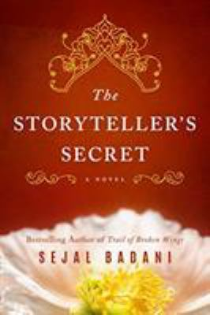
The Storyteller’s Secret by Sejal Badani

Synopsis
Nothing prepares Jaya, a New York journalist, for the heartbreak of her third miscarriage and the slow unraveling of her marriage in its wake.
Desperate to assuage her deep anguish, she decides to go to India to uncover answers to her family’s past. Intoxicated by the sights, smells, and sounds she experiences, Jaya becomes an eager student of the culture.
But it is Ravi—her grandmother’s former servant and trusted confidant—who reveals the resilience, struggles, secret love, and tragic fall of Jaya’s pioneering grandmother during the British occupation. Through her courageous grandmother’s arrestingly romantic and heart-wrenching story, Jaya discovers the legacy bequeathed to her and a strength that, until now, she never knew was possible

Discussion questions
- In the beginning of the novel, we read of Jaya’s miscarriages and the collapse of her marriage. Jaya and her husband have different ways of coping with their pain. How did their coping mechanisms differ? How did they contribute to the breakdown of their marriage?
- Jaya travels to India in the hopes of discovering her family’s long held secrets. She reflects that after knowing her past, she is ready for the future. How does uncovering your family’s past affect your life?
- Ravi still carries guilt from decisions he made decades ago. Did he do the right thing both times? How might the characters lives look if he had chosen differently? Are there any other moments in the novel where events could have been drastically different if a character made a different decision?
- Jaya ponders: “maybe life is a series of decisions with destiny thrown in.” Do you agree? Do you believe we control our stories with decisions, or are our fates pre-determined by destiny?
- Amisha’s husband Deepak’s attitude towards her and her work at the school changes several times in the novel. What does this say about how Deepak views his wife? Does he love her? Does he understand her?
- At the heart of this epic story is love...the fierce and immeasurable love Amisha had for her children and the romantic love she had for Stephen. Discuss how these two loves in her life made her feel. Were they in conflict with each other? Did she feel like she had to choose?
- What was your reaction to Amisha not telling Stephen the truth? Did she make the best choice? Did she have a choice?

Synopsis/Discussion questions from https://www.sejalbadani.com/thestorytellerssecret

