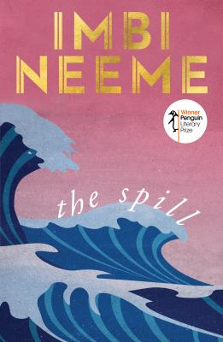
The Spill by Imbi Neeme

Synopsis
In 1982, a car overturns on a remote West Australian road. Nobody is hurt, but the impact is felt for decades.
Nicole and Samantha Cooper both remember the summer day when their mother, Tina, lost control of their car – but not in quite the same way.
It is only after Tina’s death, almost four decades later, that the sisters are forced to reckon with the repercussions of the crash. Nicole, after years of aimless drifting, has finally found love, and yet can’t quite commit. And Samantha is hiding something that might just tear apart the life she’s worked so hard to build for herself.

Discussion questions
- The author uses a non-linear chronology to represent pieces of the narrative puzzle falling into place – withholding pieces of information until characters are ready to digest them. What did you think of this choice?
- Sisters are a regular motif in fiction. Why do you think that is? Nicole and Samantha’s relationship is at the heart of the novel. How does it change over time and why do you think that is?
- Samantha may be read as not easy to love. In what ways do you think her behaviour is influenced by, or even directed by, her upbringing, genetics, her current situation or the secrets she is keeping?
- What do you think about the idea of ‘difficult’ characters in general? Is it essential that a character be ‘likeable’?
- The Spill explores themes of trust, betrayal, loyalty and what constitutes a family. Which of these themes stood out to you the most and why?
- The characters keep many secrets from each other. Do you think this is to protect themselves or the people around them? Discuss how far people should go to shield their loved ones from the truth.
- On reading The Spill, writer Robert Lukins said, 'These are people, like us, making lives of their messes.' What do you think of this summation of the book?
- Share your thoughts about the book's final revelation. Why do you think Tina never told Nicole or Samantha (or Craig or Meg) that she knew about Craig and Meg? What do you think about the fact that they will never know?

Synopsis/Discussion questions from https://www.penguin.com.au/book-clubs/2676-the-spill-book-club-notes

