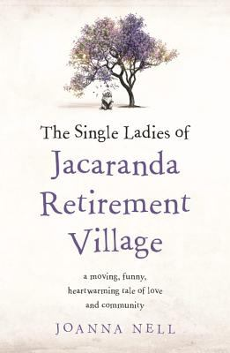
The Single Ladies of Jacaranda Retirement Village by Joanna Nell

Synopsis
The life of 79-year-old pensioner Peggy Smart is as beige as the decor in her retirement village. Her week revolves around aqua aerobics and appointments with her doctor. Following a very minor traffic accident, things have turned frosty with her grown-up children and she is afraid they are trying to take away her independence.
The highlight of Peggy's day is watching her neighbour Brian head out for his morning swim. She dreams of inviting the handsome widower - treasurer of the Residents' Committee and one of the few eligible men in the village - to an intimate dinner. But why would an educated man like Brian, a chartered accountant no less, look twice at Peggy? As a woman of a certain age, she fears she has become invisible, even to men in their eighties.
But a chance encounter with an old school friend she hasn't seen in five decades - the glamorous fashionista Angie Valentine - sets Peggy on an unexpected journey of self-discovery.

Discussion questions
- Which character do you identify more with, Peggy or Angie, and why?
- At the beginning of the book, Peggy and Angie have very different attitudes to growing old. How do you relate to the ageing process, either personally or through the people you know?
- Throughout the book, Peggy reflects on her relationship with her adult children, namely her desire for independence vs their concern about her safety. Have you had experience of this particular dilemma?
- What do Peggy’s malapropisms reveal about her character and which is your favourite?
- Peggy and Angie were friends as children, young women and then again in later life. What does the book say about friendship, and female friendships in particular?
- The novel opens with Peggy admiring Brian from afar. How does their relationship develop through the book, and what does it say about love in older age?
- If you live in a retirement village, what are the similarities and differences between where you live and Jacaranda Retirement Village? If you don’t, how do you feel about living in such a community after reading the book?
- Towards the end of the book, a major secret is revealed. How would you have reacted if you were in Peggy’s shoes?
- What lessons will you be taking away from this book?

Synopsis/Discussion questions from https://www.joannanell.com/the-single-ladies-of-jacaranda-reti

