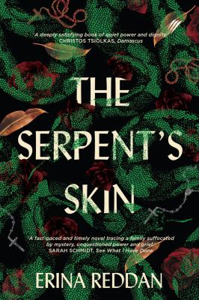
Serpents Skin By Erina Reddan
Synopsis
It’s a cold and wintery night in 1968 and ten-year-old JJ’s mother isn’t home. The cows are milked, the pigs fed, and her dad won’t answer any questions.
Sarah is the lifeblood of their family, and her absence throws everyone off course: Tessa takes charge, Tim makes mistakes, Philly retreats, and JJ blames herself. Their father works hard to keep up appearances, but something’s not right. It’s always been JJ’s job to cause trouble, and when she can’t leave the clues alone, her sleuthing wreaks havoc in their tight-knit community, and she swears off troublemaking for good.
Fourteen years on, JJ has a new life, a loving partner and a good job. But she puts it all in jeopardy when she stumbles across a chance to solve the dark mystery of her childhood. While pretending to have made peace with it, she organises a final farewell for her mother so they can all put the past behind them. Will the explosive truth finally set them free?

Discussion questions
- Which McBride sibling do you find most relatable?
- JJ is accused by those around her as being a troublemaker, both when she is a child and as an adult. Do you think this is fair? How do you think this has affected her?
- There is a strong presence of animals in this story – as well as the titular snakes, there’s also the piglets, the joey, the ferrets, crows, the grey brumby, Doll the dog and Max the bull. Choose an animal and explain what it contributes to the story.
- How do gender roles affect the members of the McBride family? The women in this novel all display different kinds of strength. What do you think the book has to say about womanhood and girlhood? And, how is masculinity depicted?
- How do Jacks avlues inform his actions? Can they be seen as a justification?
- Why do you think JJ was more driven to uncover the truth than the rest of her family?
- JJ is reading Alice in Wonderland when her mother disappears. Fourteen years later, her sister is reading the same book. What significance does this have?
- Why do you think the community labelled Peg as a mad woman? Do you think she was?

Discussion questions from https://www.panterapress.com.au/product/the-serpents-skin/#tab_resources

