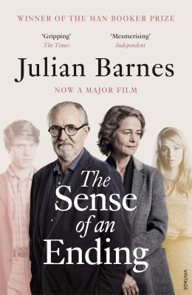
The Sense of an Ending by Julian Barnes

Synopsis

This intense novel follows Tony Webster, a middle-aged man, as he contends with a past he never thought much about—until his closest childhood friends return with a vengeance: one of them from the grave, another maddeningly present.
Tony thought he left this all behind as he built a life for himself, and his career has provided him with a secure retirement and an amicable relationship with his ex-wife and daughter, who now has a family of her own.
But when he is presented with a mysterious legacy, he is forced to revise his estimation of his own nature and place in the world.

Discussion questions
- The novel opens with a handful of water-related images. What is the significance of each? How does Barnes use water as a metaphor?
- The phrase “Eros and Thanatos,” or sex and death, comes up repeatedly in the novel. What did you take it to mean?
- At school, Adrian says, “we need to know the history of the historian in order to understand the version that is being put in front of us” (p. 13). How does this apply to Tony’s narration?
- Why did Tony warn Adrian that Veronica “had suffered damage a long way back?” (p. 46). What made him suspect such a thing? Do you think he truly believed it?
- In addition to Adrian’s earlier statement about history, Barnes offers other theories: Adrian also says, “History is that certainty produced at the point where the imperfections of memory meet the inadequacies of documentation” (p. 18), and Tony says, “History isn’t the lies of the victors . . .It’s more the memories of the survivors, most of whom are neither victorious nor defeated” (p. 61). Which of these competing notions do you think is most accurate? Which did Tony come to believe?
- Why does Mrs. Ford make her bequest to Tony, after so many years? And why does Veronica characterize the £500 as “blood money”?
- After rereading the letter he sent to Adrian and Veronica, Tony claims to feel remorse. Do you believe him? What do his subsequent actions tell us?
- Discuss the closing lines of the novel: “There is accumulation. There is responsibility. And beyond these, there is unrest. There is great unrest” (p. 163).
Synopsis/Discussion questions from https://www.penguinrandomhouse.com/books/214847/the-sense-of-an-ending-by-julian-barnes/9780307947727/readers-guide/

