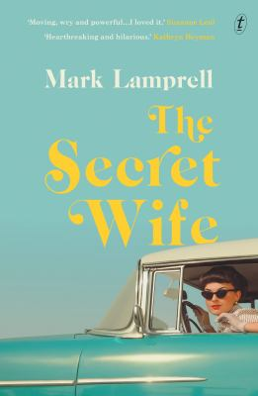
The Secret Wife by Mark Lamprell

Synopsis
In 1961, on the day that Yuri Gagarin becomes the first human to rocket into outer space, Edith Devine moves into her brand-new suburban home—and meets her new neighbour, Frankie Heyman. Frankie is a glamorous, sophisticated foil to the quiet, clever Edith, and the two housewives become firm friends.
Then, when Frankie’s domineering husband Ralph refuses to let her get a job, Edith hatches a plan to keep her friend’s household running while Frankie secretly goes out to work—and so Edith becomes Frankie’s secret wife. As Frankie builds a business empire, Edith runs both their homes: dusting, cleaning and cooking her way through the sexual revolution, the summer of love and the second wave of feminism. Throughout the 1960s, the world’s great events seem to be mirrored in the lives of two women—until the day in 1969 when the first humans step out onto the surface of the moon, and Frankie and Edith face a calamitous reckoning.
The Secret Wife is an irresistible story of fierce love, unconditional sacrifice and the transcendent power of pulling together.

Discussion questions
- Frankie and Edith’s circumstances reflect the lived experience of many women during the 1960s and ’70s. Was there anything about their story and the situations they faced that still feels relevant today?
- What are Edith’s motivations for becoming Frankie’s secret wife? Do you think there’s more to it than helping a friend?
- How does Edith’s attitude towards gender equality change throughout the novel? What are the events and situations that have the largest impact in changing her views?
- The power of female friendship is at the heart of this story. In your opinion, what makes for a long-lasting friendship?
- Frankie and her husband have very different political views. What do you think brought them together initially? Do you believe there are genuine feelings between the two of them?
- How do the characters’ circumstances change from the ’60s to the ’70s? If you lived during this time, what key world events do you remember? Where were you when they occurred?
- Truth and secrecy are explored in various ways throughout the novel. What does this story tell us about the power of living authentically? Are there times when it’s essential to keep secrets? Are any of those more particular to women?

Discussion questions from https://www.textpublishing.com.au/books/the-secret-wife

