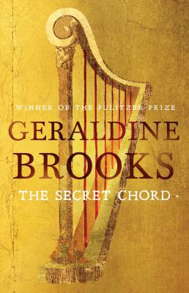
The Secret Chord by Geraldine Brooks

Synopsis
Brooks takes on one of literature’s richest and most enigmatic figures: a man who shimmers between history and legend. Peeling away the myth to bring David to life in Second Iron Age Israel, Brooks traces the arc of his journey from obscurity to fame, from shepherd to soldier, from hero to traitor, from beloved king to murderous despot and into his remorseful and diminished dotage.
The Secret Chord provides new context for some of the best-known episodes of David’s life while also focusing on others, even more remarkable and emotionally intense, that have been neglected.We see David through the eyes of those who love him or fear him—from the prophet Natan, voice of his conscience, to his wives Mikal, Avigail, and Batsheva, and finally to Solomon, the late-born son who redeems his Lear-like old age.

Discussion questions
- Natan’s first prophecy spares him from certain death but also sets him apart from other men. Is his ability a gift or a curse?
- How does David’s childhood inform your understanding of the man he will become?
- What might it mean that God chose to bestow so much upon a man as imperfect as David?
- Do you believe that some people are chosen to speak in God’s name? What role do prophets play in the events of man?
- Would David make a good leader today? Why or why not?
- What is David’s worst crime? His greatest achievement?
- Which of David’s wives do you believe suffered the most at his hands? Did he love Yonatan more than any of them? If so, why might that be?
- David is a man driven by passion and violence, but he loves God with equal fervor. How would you explain this?
- Are you familiar with the psalms attributed to David? If so, do you have a favorite?
- What might David have done if he had known that Natan was hiding what he knew about his sons’ futures? Would David hesitate to kill Natan if he felt the prophet had betrayed him?
- What is the nature of Natan’s feelings toward David? Would you be able to serve a man like him?
- What is “the secret chord”? Why did Brooks choose this phrase as the novel’s title?
Discussion questions from https://www.penguinrandomhouseaudio.com/discussion-guide/310470/the-secret-chord/

