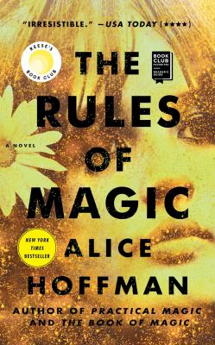
The Rules of Magic by Alice Hoffman

Synopsis
Find your magic.
For the Owens family, love is a curse that began in 1620, when Maria Owens was charged with witchery for loving the wrong man.
Hundreds of years later, in New York City at the cusp of the sixties, when the whole world is about to change, Susanna Owens knows that her three children are dangerously unique. Difficult Franny, with skin as pale as milk and blood red hair, shy and beautiful Jet, who can read other people's thoughts, and charismatic Vincent, who began looking for trouble on the day he could walk.
From the start Susanna sets down rules for her children: No walking in the moonlight, no red shoes, no wearing black, no cats, no crows, no candles, no books about magic. And most importantly, never, ever, fall in love. But when her children visit their Aunt Isabelle, in the small Massachusetts town where the Owens family has been blamed for everything that has ever gone wrong, they uncover family secrets and begin to understand the truth of who they are. Yet, the children cannot escape love even if they try, just as they cannot escape the pains of the human heart. The two beautiful sisters will grow up to be the memorable aunts in Practical Magic, while Vincent, their beloved brother, will leave an unexpected legacy.

Discussion questions
- We learn that the rules of magic are to harm no one, remember that what you give will be returned to you threefold, and fall in love whenever you can. Do Franny, Jet, and Vincent live by these rules? What happens when they break them? What set of rules would you live by?
- Alice Hoffman's novels are often woven with qualities that earn them a place in the genre of magical realism. Discuss how she achieves this writing style. What details do you notice she includes? What sources of inspiration does she draw from?
- Frances in particular seems to wrestle the most with the curse, even with her Maid of Thorns reputation. Why is this so? Why do you think she can't embrace love the way her siblings do?
- One summer night while walking his dog, Harry, Vincent stumbles upon the Stonewall riots, often recognized as the origin of the gay rights movement in the United States. What do you know about this historical event? Do you think the revolt changed him? How do the riots contrast with Vincent and William's trip to California during the Summer of Love?
- Jet also wanders through a historical event inspired by the Human Be-In, held in Central Park on Easter Sunday of 1967. She accidentally ingests LSD and almost drowns herself in one of the park's ponds. What brought Jet to this moment? Would you consider it her rock bottom?
- Vincent's fate is altered when he is drafted to Vietnam in one of the country's most unpopular and controversial wars. Do you think his sisters did the right thing by smuggling him out of the country? What would you have done if you or a loved one were drafted at the time?
Discussion questions from https://www.bookbrowse.com/reading_guides/detail/index.cfm/book_number/3657/the-rules-of-magic

