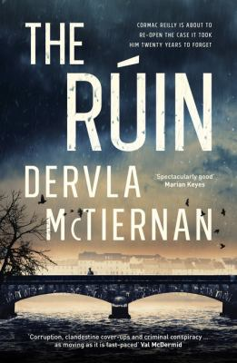
The Ruin by Dervla McTiernan

Synopsis
It has been twenty years since young Irish police officer Cormac Reilly discovered the body of Hilaria Blake in her decaying mansion, and he has never forgotten the two neglected children she left behind. Now, having recently moved to Galway as a Detective, Reilly is instructed to reopen the cold case. The case has links to the recent death of a young man - a death which the police are very quick to claim is suicide. The deceased man’s long lost sister arrives and suspects foul play, and she is determined to prove it.
Trust and betrayal are at the heart of this unsettling, fast-paced, intricately plotted detective novel. Mystery, intrigue, complex twists and turns, police corruption, and Ireland’s dark history of child abuse ─ this atmospheric crime novel has it all.

Discussion questions
- The troubled, self-medicating protagonist is a familiar character in crime fiction. Cormac Reilly differs greatly from this: he is calm, methodical and committed in his work, a supportive partner, and a nice person with a good heart. Why do you think the author created this sort of main character?
- Some crime novels take the reader on a journey of discovery, one clue at a time, the reader only ever knowing as much as the characters who are investigating. Others let the reader in on secrets while the characters are still in the dark. What is your preference?
- As the story reaches its conclusion, we discover that two of the characters have managed to keep their true characters hidden for many years despite committing appalling acts. How have they managed this? Can you think of real life examples of this situation?
- Many aspects of modern Ireland’s unique history are part of the fabric of The Rúin: unwanted children, adoption, abortion, abuse, and the inability of the authorities to protect children. What does the author’s depiction of these aspects say about this history and its continuing impact on the country?
- Given their difficult childhoods, how could the Maude and Tom characters have turned out differently?
- Cormac is not only new to his colleagues in Galway, but he is also an outsider. Why is that? How does that impact on his investigation?
- Discuss how the author represents the garda in this novel. How does this differ from some other ‘police procedurals’?
- For the most part, the novel is told through the alternating point of view of Cormac and Aisling. Then in one chapter, we see from Maude’s point of view and in in another from Tom’s. What are the advantages of this approach?

Discussion questions from https://www.writingwa.org/for-readers/book-club/the-ruin-dervla-mctiernan-harper-collins/

