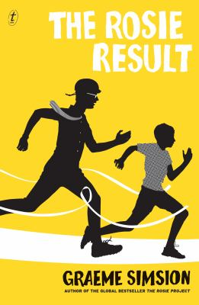
The Rosie Result by Graeme Simsion

Synopsis
If the storylines in ‘The Rosie Result’ centre on Don’s challenges in trying to parent the son who shares many similarities with him, the main theme that the novel grapples with is labelling and identity, specifically in relation to autism, but more broadly too. The novel also directly questions many people’s assumptions about what autistic people are like, how they behave, what they understand and who they are.
This questioning takes place most obviously in the support-group scene, where the mother of a previously non-verbal daughter and an autism activist articulate the different ways they approach autism. But the questioning can be found throughout the book, including in Don’s thoughts. Should he and Rosie have Hudson assessed? What are the benefits and disadvantages of a diagnosis? Should autistic people have to adjust their behaviour and thinking to match neurotypical norms? Does it make their lives better or worse if they do?
As Don ponders these questions, he is trying to be the best parent he can be. He remembers his own experiences as a child and an adult, wondering what would have made things better for him. And he starts thinking about his father too, understanding and valuing some of what his father did for him, but also trying to come up with a new and better way to be a parent – more specifically to be a parent to Hudson. And he realises that Hudson is similar to him, but not the same as him.

Discussion questions
- Much of the humour in the Rosie books comes from Don misreading social situations and cues. How does Simsion make us laugh at Don’s interpretations and the comedy that follows from them without making us laugh at Don himself? Or doesn’t he?
- Professor Lawrence tells Don that as a ‘straight, white, middle-aged male who’s spent his life in top western universities’, he is ‘the definition of privilege’ (23). Do you agree? Does his autism affect his status?
- When thinking about his parenting, Don thinks about what he would have wanted at Hudson’s age, and decides ‘I would have wanted to be treated as an adult…to be properly informed, listened to and involved in decisions affecting me’ (73). Is this what most children want? Is it possible to give it to them?
- Don values rational thinking as ‘arguably life’s most important skill’ (117), and sees emotion as its opposite (182). What do you think?
- Discuss what else the book says about parenting. Consider, for example, Don’s recognition that he needs to ‘outsource’ some of the support he gives Hudson. Or how one’s parenting is influenced by one’s own parents.
- Don has spent a lifetime trying to fit in (368), but eventually realises he doesn’t want Hudson to have to do the same. How much should people – whether autistic or neurotypical – try to ‘fit in’ and modify their behaviour to get on with others? How much should the world accommodate difference?
Synopsis/Discussion questions from https://www.textpublishing.com.au/books/the-rosie-result

