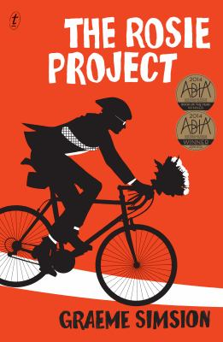
The Rosie Project by Graeme Simsion

Synopsis
Don Tillman is a professor of genetics in Melbourne. He’s socially awkward, wears quick-dry clothing and the best four days of his adult life to date have been spent at the Museum of Natural History in New York. He eats the same lobster meal every single Tuesday night and he times his showers to the second. He’s never been on a second date, and a series of dating disasters has convinced him that it’s unlikely he ever will. Then a chance encounter gives him an idea: What if he designed a scientifically researched questionnaire that was guaranteed to find him the perfect partner? And with that, the Wife Project is born.
There are only two problems with Don’s methodology: a) many women fill in the questionnaire but no one satisfies Don’s strict criteria b) for some reason he is spending all of his time on the Rosie Project instead. Rosie Jarman is also looking for someone. She’s determined to find her biological father, a search that a certain DNA expert might be able to help her with. Rosie is fiery, intelligent and extremely attractive. She also fails almost every single criterion of the Wife Project. It’s clear to Don that she is totally unsuitable as a life partner. Luckily, Rosie doesn’t seem all that interested in Don either. Instead, they embark on the Father Project and a series of richly comic mishaps unfold as they attempt to collect the DNA of Rosie’s various—and unsuspecting—potential fathers

Discussion questions
- The Rosie Project is about becoming open to seeing things from a different angle: Don must reconsider his strict criteria in order to find love, Gene needs to revaluate his behaviour in order to save his marriage, and Rosie has her own set of prejudices and expectations to overcome in terms of Don and her non-biological father, Phil. What was stopping the characters from making these discoveries earlier? Did the novel change your own perspective on anything?
- Don’s 16-page questionnaire for prospective partners elicits a very different reaction from Rosie and Bianca. Rosie is offended and claims that it objectifies women, while Bianca says it is nice to finally meet a man who is more interested in her than himself. What do you think?
- Does the humour in the novel come from Don’s awkward responses to social situations or the absurdity of falling in love in general? Do you feel as though you are laughing with Don or at Don?
- Imagine the book had been written from Rosie’s perspective. Would it have been as enjoyable? Would you have understood Don’s actions and behaviour had he not been the narrator?
- At what point do you think Rosie starts to view Don as a prospective partner? Did your own feelings towards Don change at a particular point in the novel?
- The Rosie Project can be read as a novel about tolerance and acceptance, but it also makes a case for people to take control of how others perceive them and change their behaviour if necessary. Do you agree with this view? To what extent do you think Don changes himself for Rosie?
Synopsis/Discussion questions from https://www.textpublishing.com.au/books/the-rosie-project

