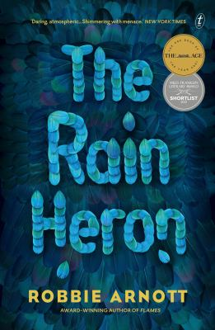
The Rain Heron by Robbie Arnott

Synopsis
Ren lives alone on the remote frontier of a country devastated by a coup. High on the forested slopes, she survives by hunting and trading—and forgetting.
But when a young soldier comes to the mountains in search of a local myth, Ren is inexorably drawn into her impossible mission.
As their lives entwine, unravel and erupt—as myths merge with reality—both Ren and the soldier are forced to confront what they regret, what they love, and what they fear.

Discussion questions
- Why do you think the first section of the novel is called Part 0, rather than Part 1? Is this short section a fable that long predates the action of the book, possibly an oral history or origin story, or could it be a recollection by one of the book’s characters, or something else again?
- Ren’s interactions with Barlow and his son on the mountain suggest a post-capitalist return to a barter economy. But the trades they make are rarely equal; instead, the parties are offering each other kindness and safety. Does this make the mercenary Zoe Harker, with her cruel tactics to subjugate people and the environment, seem even more terrifying when she finally breaks the will of Ren, the peaceful hermit?
- Ren mentions a son she fell out with after the coup, before she fled to live alone on the mountain. Is it possible that Alec, whom we meet in Part 4 and who talks to Zoe Harker about falling out disastrously with his mother, is that son? Discuss why this link might not have been made explicit in the text.
- Were you surprised when Ren reappeared at the end of the novel—had you assumed that she died on the mountain? She has lost the ability to speak, yet her spirit seems undaunted. Zoe Harker, by contrast, lost an eye to the rain heron and has been profoundly affected by this. Discuss the portrayals of physical and mental strength in these characters: are they very different people or, as Ren implies, perhaps more similar than Zoe cares to realise?
- The Rain Heron describes a world irrevocably altered by climate change—principally in Part 2, where the unnamed port city Zoe Harker grew up in loses the driver of its economy, farmed squid ink, and falls into disrepair. Later in the novel, though, Daniel the medic appears to find the region around his family farm in good order. Is this a story set against the backdrop of ecological catastrophe, or is the picture more complicated?
- The heron is presented as a creature of unparalleled splendour, a source of wonder; yet it is also capable of extreme violence. Does the novel seek to remind us of the essential non-humanness of nature, its beauty and its brutality? Equally, does the heron possess godlike characteristics, or might its powers have been misapprehended by humans?

Synopsis/Discussion questions from https://www.textpublishing.com.au/books/the-rain-heron

