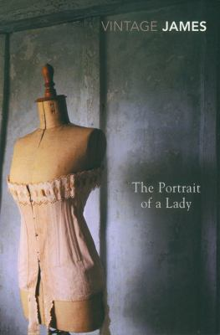
The Portrait of a Lady by Henry James

Synopsis
One of the great heroines of American literature, Isabel Archer, journeys to Europe in order to, as Henry James writes in his 1908 Preface, "affront her destiny."
James began The Portrait of a Lady without a plot or subject, only the slim but provocative notion of a young woman taking control of her fate. The result is a richly imagined study of an American heiress who turns away her suitors in an effort to first establish—and then protect—her independence.
But Isabel’s pursuit of spiritual freedom collapses when she meets the captivating Gilbert Osmond.

Discussion questions
- Women who display independence and individualism seem to be an oddity in England. What early hints are we given that Isabel might upset long established social strictures by her insistence on her own freedom?
- A major theme explored in Henry James's novels is the difference between American and European cultures and sensibilities. How do those differences play out in this novel?
- Why does Isabel reject both Warburton's and Casper Goodwood's proposals of marriage?
- Why does Ralph request that his father leave Isabel half of his fortune? Why does Isabel, later in San Remo, tell Ralph that she thinks the fortune may be bad for her?
- Discuss Madame Merle—her talents, personality, her attitudes toward her own life, society, and money. What does Mrs. Touchett think of her and what do Ralph and Isabel think of her? American born, where does Merle stand in the American vs. European dichotomy that Henry James sets up.
- What attracts Isabel to Gilbert Osmond? What does Ralph think of think of him? Which endangers Isabel more—her fortune or her overly romantic imagination?
- Talk about the way that Merle and Osmond manipulate Isabel. Why is Isabel so oblivious to their schemes? Notice, though, Isabel's thoughts when she arrives at Osmond's villa: that it would be a very difficult place to get out of. In what way does James use a person's surroundings as an indication of his character?
- Three years into Isabel and Osmond's marriage, what has happened? What is the couple's relationship? How does Osmond treat Isabel? And where does Madam Merle stand in all of this—what do we eventually come to learn about her and Osmond's history?
- Finally, Isabel returns to England to be with Ralph as he dies. Why does Isabel see the ghost this time? And most important, why does Isabel make the decision she does at the end?

Discussion questions from https://www.litlovers.com/reading-guides/13-reading-guides/fiction/807-portrait-of-a-lady-james?showall=1

