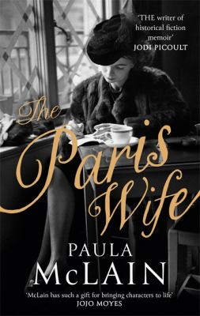
The Paris Wife by Paula McLain

Synopsis
Chicago, 1920: Hadley Richardson is a quiet twenty-eight-year-old who has all but given up on love and happiness—until she meets Ernest Hemingway and her life changes forever. Following a whirlwind courtship and wedding, the pair set sail for Paris, where they become the golden couple in a lively and volatile group—the fabled “Lost Generation”—that includes Gertrude Stein, Ezra Pound, and F. Scott and Zelda Fitzgerald.
Though deeply in love, the Hemingways are ill prepared for the hard-drinking and fast-living life of Jazz Age Paris, which hardly values traditional notions of family and monogamy. Surrounded by beautiful women and competing egos, Ernest struggles to find the voice that will earn him a place in history, pouring all the richness and intensity of his life with Hadley and their circle of friends into the novel that will become The Sun Also Rises.
Hadley, meanwhile, strives to hold on to her sense of self as the demands of life with Ernest grow costly and her roles as wife, friend, and muse become more challenging. Despite their extraordinary bond, they eventually find themselves facing the ultimate crisis of their marriage—a deception that will lead to the unraveling of everything they’ve fought so hard for.

Discussion questions
- Hadley and Ernest don't get a lot of encouragement from their friends and family when they decided to marry. What seems to draw the two together?
- The Ernest Hemingway we meet in The Paris Wife—through Hadley's eyes—is in many ways different from the ways we imagine him when faced with the largeness of his later persona. What do you see as his character strengths? Can you see what Hadley saw in him?
- At one point, Ezra Pound warns Hadley that it would be a dire mistake to let parenthood change Ernest. Is there a nugget of truth behind his concern? What are some of the ways Ernest is changed by Bumby's birth? What about Hadley? What does motherhood bring to her life, for better or worse?
- One of the most wrenching scenes in the book is when Hadley loses a valise containing all of Ernest's work to date. What kind of turning point does this mark for the Hemingway's marriage?
- In The Paris Wife, when Ernest receives his contract for In Our Time, Hadley says, "He would never again be unknown. We would never again be this happy." How did fame affect Ernest and his relationship with Hadley?
- What was the nature of the relationship between Hadley and Pauline Pfeiffer? Were they legitimately friends? How do you see Pauline taking advantage of her intimate position in the Hemingway's life? Do you think Hadley is naive for not suspecting Pauline of having designs on Ernest earlier?
- In many ways, Hadley is a very different person at the end of the novel than the girl who encounters Ernest by chance at a party. How do you understand her trajectory and transformation? Are there any ways she essentially doesn't change?
Synopsis/Discussion questions from https://www.litlovers.com/reading-guides/13-reading-guides/fiction/8093-paris-wife-mclain?showall=1

