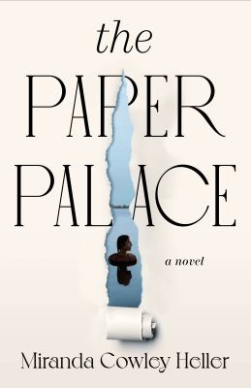
The Paper Palace by Miranda Cowley Heller

Synopsis
Before anyone else is awake, on a perfect August morning, Elle Bishop heads out for a swim in the glorious fresh water pond below 'The Paper Palace' - the gently decaying summer camp in the back woods of Cape Cod where her family has spent every summer for generations. As she passes the house, Elle glances through the screen porch at the uncleared table from a dinner party the previous evening; empty wine glasses, candle wax on the table cloth, echoes of laughter of family and friends. Then she dives beneath the surface of the freezing water to the shocking memory of the sudden passionate encounter she had the night before, up against the wall outside the house, as her husband and mother chatted to the dinner guests inside.
So begins a story that unfolds over 24 hours and across 50 years, as decades of family legacies, love, lies, secrets, and one unspeakable incident in her childhood lead Elle to the precipice of a life-changing decision. Over the next 24 hours, Elle will have to decide between the life she has made with her much-loved husband, Peter, and the life she imagined would be hers with her childhood love, Jonas, if a tragic event hadn't forever changed the course of their lives.

Discussion questions
- In The Paper Palace, desire and duty are put to the test when Elle Bishop has to choose between the life she always believed she was meant to have with her oldest friend Jonas, and the life she has with her loving husband Peter. Compare and contrast Elle’s relationship with both.
- The novel unfolds over twenty-four hours, and fifty years: one day in Elle’s life, and the moments that lead to this day. What do we gain through multiple timelines that we otherwise would not?
- In the multigenerational story, we see the reverberations of the choices made by grandparents and parents, and the scars they have left on Elle herself. In what way do those scars reveal themselves, and is it possible to break the cycle?
- The individuals who find themselves at The Paper Palace are as susceptible to the elements as the house is. Consider adult Elle and Jonas’s intimate beach scene, their dangerous sailing trip, etc. What role do nature and the weather play in the story? How is the outside, natural world used to echo Elle’s interior journey?
- Secrets are at the heart of the novel: the acts that create them, the decisions to keep them hidden. What is the outcome of keeping secrets and how do we see that play out within the novel? Why do you think Elle keeps the secrets that she does from her family? From Peter? Think of a time when you kept a secret. Was it harmful or helpful?
- The novel is called The Paper Palace. Why? What parallels exist between the camp and the people who inhabit it?
- How did you interpret the ending? For you, was the major plot of the novel about Elle choosing between two men, or choosing different versions of herself? Explain.
Synopsis/Discussion questions from https://www.penguinrandomhouse.com/books/667307/the-paper-palace-by-miranda-cowley-heller/9780593329832/readers-guide/

