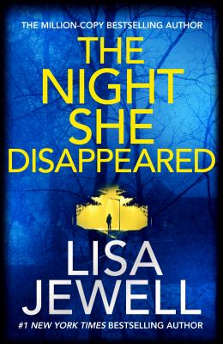
The Night She Disappeared by Lisa Jewell

Synopsis
Midsummer 2017: teenage mum Tallulah heads out on a date, leaving her baby son at home with her mother, Kim.
At 11pm she sends her mum a text message. At 4.30am Kim awakens to discover that Tallulah has not come home
Friends tell her that Tallulah was last seen heading to a pool party at a house in the woods nearby called Dark Place
Tallulah never returns.
2018: walking in the woods behind the boarding school where her boyfriend has just started as a head-teacher, Sophie sees a sign nailed to a fence.
A sign that says: DIG HERE . . .

Discussion questions
- The novel is written primarily from Tallulah, Kim, and Sophie’s points of view. Whose voice were you most captivated by? Did you prefer one narrator over another?
- Lisa Jewell includes many heart-wrenching moments in which Kim grieves the loss of her daughter. What details did you find the most poignant?
- Although at first Scarlett seems very charming, in many ways she is just as controlling as Zach. From luring Tallulah away at the school party to getting the TM tattoo (which, whether interpreted as Tallulah’s initials or as “trademark,” indicates possessiveness) to influencing Tallulah’s break-up, Scarlett’s ultimate control over her is foreshadowed throughout the novel. Was there a specific turning point when you began to worry about Scarlett’s hold over Tallulah?
- Zach and Scarlett are not the only two characters who confuse love and control. Who else struggles to find balance in their relationships? Which characters have a healthy understanding of what real love entails?
- Liam’s secret remains hidden until the last pages of the book. Did you guess what he was hiding from everyone?
- Toward the end of the novel, Kim tells herself that despite Scarlett’s confession and possible imprisonment “Kim cannot feel sorry for her or care about her fate, as young as she is, as much as Scarlett may claim to love her daughter. She simply cannot” (page 392). After getting to know Scarlett over the course of the novel, do you feel sorry for her? Who do you think is more at fault, Scarlett or Joss Jacques?

Discussion questions from https://www.simonandschuster.com/books/The-Night-She-Disappeared/Lisa-Jewell/9781982137373

