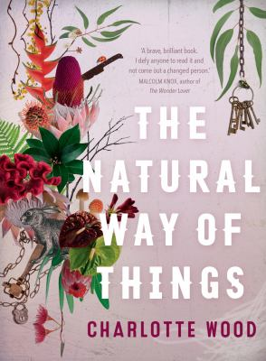
The Natural Way of Things by Charlotte Wood

Synopsis
Two women awaken from a drugged sleep to find themselves imprisoned in a broken-down property in the middle of nowhere. Strangers to each other, they have no idea where they are or how they came to be there with eight other girls, forced to wear strange uniforms, their heads shaved, guarded by two inept yet vicious armed jailers and a ‘nurse’.
The girls all have something in common, but what is it? What crime has brought them here from the city? Who is the mysterious security company responsible for this desolate place with its brutal rules, its total isolation from the contemporary world? Doing hard labour under a sweltering sun, the prisoners soon learn what links them: in each girl’s past is a sexual scandal with a powerful man.
They pray for rescue - but when the food starts running out it becomes clear that the jailers have also become the jailed. The girls can only rescue themselves…

Discussion questions
- ‘You need to know what you are’ (p.18). Consider this statement by Boncer. ‘What’ are these girls – to society, the media, the guards, their families and partners? And how do these conflicting perceptions ultimately shape the girls’ sense of self? 
- Compare and discuss your interpretations of ‘Hardings International’. Who or what do they represent? And why do they want these girls removed from society? 
- In what ways do you think gender impacted your reading of the book? If you have men and women in your reading group, discuss the different ways you related and reacted to the characters and events in the novel. 
- Consider the developing relationship between Yolanda and Verla. What brings them together and, ultimately, sets them apart? 
- Discuss the ways the book addresses issues surrounding the female body. How do the girls view their bodies? In what ways are they sites of both power and oppression? 
- ‘Animal blood and guts, the moon and the season. It was beyond her named self, beyond girl, or female. Beyond human, even.’ (p. 193) What power and promise does the animal world increasingly hold for Yolanda? How does going back to a primitive state enable her understand herself and her world?
- Consider the conflicting representations of violence throughout the book. How does it challenge the boundaries between human and animal nature? Male and female? Power and oppression?
- What is your interpretation of the final scene? Where are the girls going? And what kind of world are they leaving behind?
Discussion questions from https://www.allenandunwin.com/documents/reading-groups/591-the-natural-way-of-things-reading-group-notes

