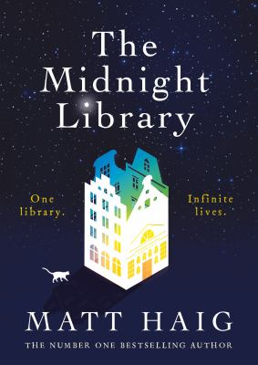
The Midnight library by Matt Haig

Synopsis
Somewhere out beyond the edge of the universe there is a library that contains an infinite number of books, each one the story of another reality. One tells the story of your life as it is, along with another book for the other life you could have lived if you had made a different choice at any point in your life. While we all wonder how our lives might have been, what if you had the chance to go to the library and see for yourself? Would any of these other lives truly be better?
In The Midnight Library, Matt Haig’s enchanting new novel, Nora Seed finds herself faced with this decision. Faced with the possibility of exchanging her life for an alternate one, following a different career, undoing old breakups, realizing her dreams of becoming a glaciologist, she must search within herself as she travels through the Midnight Library to decide what is truly fulfilling in life and what makes it worth living in the first place. Nora’s story is as challenging as it is life-affirming, and in the process of seeing all of the ways it could have gone, she has come to value the life she lived for herself all the more. But her journey raises big questions about what we value in ourselves, in our relationships, and in all our successes and failures, big and small.

Discussion questions
- The Midnight Library is different for each person who enters it. Nora experienced it as a library because of the meaningful relationship she had with Mrs. Elm, her childhood school librarian. Later, we learn that Huge experienced it as a video store, with a cherished uncle instead of a librarian. What do you think your Midnight Library would be? And who would be there?
- In the library, Nora learns that the life she gave her cat was the best he could have experienced. Are there any parts of your life that you feel could not be improved by living it differently?
- In her life before she finds herself in the Midnight Library, Nora gave up many of the pursuits that brought her joy because she didn’t feel like she could be the best at them. Do you think it’s understandable that she would have given these things up? Do you think that wanting to be the best at something can inhibit us from enjoying it?
- Mrs. Elm showed Nora the Book of Regrets when she first entered the library, and Nora was overwhelmed by it when she first looked in. But as she experienced more and more lives, her list of regrets began to shrink. Do you think by considering the ways in which our lives might have turned out differently our regrets truly go away, or do we simply learn to live with them?
- As the story progresses, Nora finds herself in lives that she could be more satisfied with than others that proved more difficult. Do you think you would be able to live as an alternate version of yourself?
- Over the course of the book, Nora lives a whole spectrum of lives, some for minutes and some for months, but only at the end does time actually pass, and by the time she wakes up in her root life it is one minute and twenty-seven seconds past midnight and her outlook on life has changed entirely. What do you think this says about the speed at which we decide things about our lives and ourselves? Does it take a lifetime or a just few seconds?
Synopsis/Discussion questions from https://www.penguinrandomhouse.com/books/575653/the-midnight-library-by-matt-haig/9780525559474/readers-guide/

