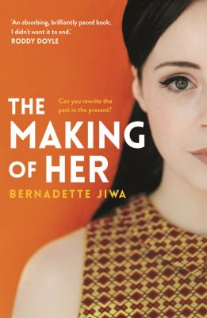
The Making of Her by Bernadette Jiwa

Synopsis
Dublin 1966. When Joan Quinn, a factory girl from the Cranmore Estate, marries Martin Egan, it looks like her dreams have come true. But all is not as it seems.
Joan lives in the shadow of a secret – the couple’s decision to give up their first daughter for adoption only months before.
For the next three decades, Joan’s marriage and her relationship with her second child Carmel suffer as a consequence.
Then one day in 1996, a letter arrives from their eldest daughter. Emma needs her birth parents’ help; it’s a matter of life and death. And the fragile facade of Joan’s life finally begins to crack.

Discussion questions
- Why do you think the novel is titled The Making of Her?
- The story is set in Dublin. In what ways do you think the city shaped the Egans' lives?
- What path do you think Joan's life would have taken if she hadn't received Emma's letter?
- How did you interpret Joan's decision to sleep with Martin before he goes to London?
- Did you empathise with Martin? And if so, when and why?
- At one point Martin asks Joan: 'Why can't we leave the past where it belongs?' Why do you think he finds this so easy to do, and Joan finds it so hard?
- Discuss the role of men throughout the story.
- Were you surprised by Emma's decision at the airport towards the end of the novel?
- What did you make of Joan and Carmel's relationship as the novel went on, and of Carmel's forgiveness?
- How does social class affect the lives of the characters in the novel?
- In this multigenerational story, we see the reverberations of the choices made by grandparents and parents, and the scars they have left on Joan, Carmel and Emma. In what ways do those scars reveal themselves, and is it possible to break the cycle?
- How did you interpret the ending? For you, was the major plot of the novel about the cost of keeping secrets or the power to choose?

Discussion questions from https://www.penguin.com.au/book-clubs/3366-the-making-of-her-book-club-notes

