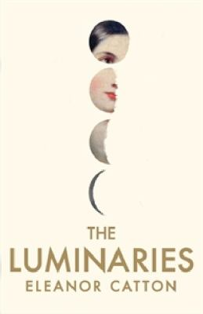
The Luminaries by Eleanor Catton

Synopsis
It is 1866, and Walter Moody has come to stake his claim in New Zealand's booming gold rush. On the stormy night of his arrival, he stumbles across a tense gathering of 12 local men who have met in secret to discuss a series of unexplained events: a wealthy man has vanished, a prostitute has tried to end her life, and an enormous cache of gold has been discovered in the home of a luckless drunk. Moody is soon drawn into a network of fates and fortunes that is as complex and exquisitely ornate as the night sky.

Discussion questions
- Do you believe in astrology? Do you attribute any part of your personality to your star sign? To what extent do you think the characters in The Luminaries are bound to their astrological signs?
- Throughout the book, people are either hurting Anna or helping her. What is it about her that makes her a litmus test for other characters’ morality?
- Do you feel that the narrator was completely trustworthy? Like her Victorian predecessors, Catton doesn’t hesitate to intersperse the narrative with moral judgments of her characters—frequently, her characters judge one another. Sometimes, the narrator “breaks the fourth wall” by addressing the audience directly. Do these techniques make the narrator more reliable than one who “feigns” neutrality? Is there ever such thing as a narrator who is completely objective?
- The Luminaries is set in a New Zealand that is rapidly changing as a result of the gold rush. Banking has become all-important, and the outside world is exerting its growing influence, resulting in the confluence of “the savage and civil, the old world and the new.” Do any of the concerns of the people in this place and time still resonate today? Are there ways in which this story could be universal?
- Some media outlets have asserted that The Luminaries is dominated by male characters and brings to life a male-dominated world with this story. Do you agree? If Catton were a man, do you think this issue would have surfaced? Should female writers have to take their own gender into account when writing?
- Eleanor Catton was born in Canada, lives in New Zealand, studied in the United States, and travels regularly. How do you think that her experiences as an international citizen have shaped her prose? Are there certain limitations or freedoms that Catton’s nationality have on her legacy as a writer?

Synopsis/Questions from https://www.hachettebookgroup.com/titles/eleanor-catton/the-luminaries/9780316074292/

