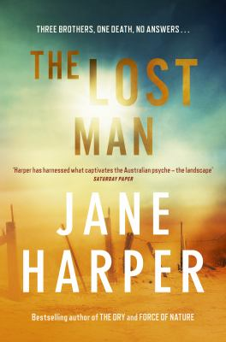
The Lost Man by Jane Harper

Synopsis
When cattle station owner Cameron Bright is found dead at an outback landmark known as the stockman’s grave, miles from anywhere and in the searing heat of a Queensland summer, most people assume he must have intended his death. Why else would he have walked away from his car, which was stocked with supplies and water, his only possible means of survival in that brutal climate? There are no signs of violence or foul play, so the local authorities conclude that he must have done, but his older brother Nathan knows something is very wrong with the picture.
Cameron ran the family’s profitable cattle station with their younger brother Bub, and had a wife and two small daughters. He was clever, successful and well liked in the local town. Suicide – especially in this manner – was out of character. Along with his teenage son, Nathan returns to his childhood home to help with the fallout from Cameron’s death. He finds that things are not quite what he expected: Cameron had been tense and distracted before he died, and there are other factors that just don’t add up. Nathan starts looking for answers, but the more he digs, the closer to home the truth seems to lie...

Discussion questions
- What effect did the lack of police and medical support have on the outcomes for the rape of Jenna Moore, and the death of Cameron Bright?
- Nathan is excommunicated from the local township when he doesn’t stop to help Keith Walker on a remote outback road. What does this have to say about the nature of small, isolated communities? What are the advantages and disadvantages of communities such as these, do you think?
- Nathan, Cameron and Bub all suffered from their father’s domestic violence against them and their mother through their childhood, but they have dealt with that abuse in very different ways as adults. What effect has that abuse had on each of the brothers? Which of them do you think has been the most successful at dealing with this traumatic childhood, and why?
- How has Nathan’s upbringing affected his approach to parenthood? How do the events of the novel influence his attitude towards how he interacts with Xander and Jacqui in the future?
- Over the course of the novel, Cameron Bright is revealed to us as someone who had both good and not so good qualities, which he hides well. What were some of the ways Cameron manipulated the people around him? Why and how did he get away with it?
- In spite of the influence Cameron had on those around him, all the other characters in the novel benefit in some way from Cameron’s death. In what ways are they now better off? Do you think this justifies Cameron’s death in any way?
- Did you suspect at any point that Liz might have been in involved in Cameron’s death? Why or why not, do you think?
- Jane Harper has chosen to tell this story in the third person past tense, entirely (with the exception of the prologue) from Nathan Bright’s point of view. What is the effect of this?
Synopsis/Discussion questions from https://www.panmacmillan.com.au/9781743549100/

