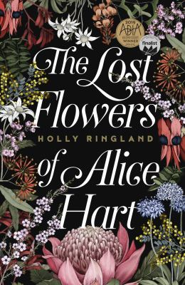
The Lost Flowers of Alice Hart by Holly Ringland

Synopsis
Nine-year-old Alice Hart lives in isolation by the sea, where her mother’s enchanting flowers and their hidden meanings mostly shelter Alice from the dark moods of her father. After tragedy changes her life irrevocably, Alice is sent to live with the grandmother she never knew existed at Thornfield, the family run native flower farm that provides a refuge to women who, like Alice, are lost or broken; in the Victorian tradition, every flower has a meaning to say what words can’t. Alice settles into her new life and learns the language of flowers to express the things that are too hard to speak.
But, as she grows older, she becomes increasingly frustrated by the secrecy surrounding her family story. In her early twenties Alice’s life is again thrown into chaos when a devastating betrayal, and a man who’s not all he seems, combine to make her realise there are some stories that flowers can't tell. Alice begins to understand that if she is to have the freedom she craves, she must find the courage to possess the most powerful story she knows: her own.

Discussion questions

- Why do you think Alice stopped talking? What does her muteness mean?
- Do you think June was right to keep so much information back from Alice? Does this make her a bad person?
- What do you think the ‘lost flowers’ in the title – The Lost Flowers of Alice Hart – refers to? Could it have multiple meanings?
- Dogs are prominent in Alice’s life. How do they reveal the nature of Alice’s character and of others, for example, Moss, and Dylan?
- What do you think motivated Oggi to write to Alice after all those years? What was his letter trying, implicitly, to tell her?
- The women in Lulu’s family passed down foresight. Honey grevillea, which grows rampant in the desert, also means foresight. What deeper meaning could be at play in how this idea is used in the novel, for example, when we can see things coming, does that necessarily empower us to do what’s right?
- Many of the characters’ appearances are disclosed, but Dylan’s is not. Why do you think this is?
- Fear and past pain shapes the lives of characters in the novel in varying ways. Discuss the characters you feel are most dictated by fear and the past.
- After the point in time where the novel ends, what do you think Charlie will do with his third of Thornfield?

Synopsis/Discussion questions from https://www.hollyringland.com/alice-hart

