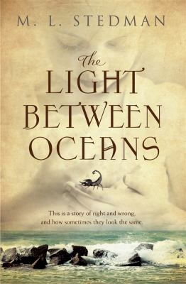
The Light Between Oceans by M.L. Stedman

Synopsis
They break the rules and follow their hearts. What happens next will break yours.
1926. Tom Sherbourne is a young lighthouse keeper on a remote island off Western Australia. The only inhabitants of Janus Rock, he and his wife Isabel live a quiet life, cocooned from the rest of the world.
Then one April morning a boat washes ashore carrying a dead man and a crying infant - and the path of the couple's lives hits an unthinkable crossroads.
Only years later do they discover the devastating consequences of the decision they made that day - as the baby's real story unfolds ...

Discussion questions
- Whose story would you say this is?
- Are any of the characters ‘bad’? If so, who? What makes a person warrant the description ‘bad’?
- Which of the characters did you have most sympathy with and why? Did it change at different times in the novel? Describe how your attitude to characters developed or switched along the way. What caused the changes?
- What would you have done in Isabel’s place: i) when the boat washed up; ii) when the Anzac Day events were revealed; and iii) when the police came to the island? What would you have done in Tom’s place at each stage?
- Discuss the impact of Isabel’s miscarriages and subsequent frame of mind on her moral and legal culpability. Is Isabel more deserving of the reader’s compassion because her actions spring from a natural and positive urge to love?
- Who has the right to forgive a wrong? Tom and Isabel are treated leniently because Hannah speaks up for them, and encourages clemency. Should victims be able to reduce the penalties handed down to wrongdoers whose actions have affected them?
- The novel is full of opposites – light and dark; ocean and land; the wild Southern Ocean and the warmer Indian Ocean; war and peace; truth and lies; guilt and redemption. Some of these have symbolic value – what role does the symbolism play? What is the impact of these ‘Janus’ pairs that run through the novel?
- Letters feature prominently in the novel. Discuss how and why the writers used them to reveal, conceal and confess.

Synopsis/Discussion question from https://www.penguin.com.au/books/the-light-between-oceans-9780857989888/book-clubs/893-light-between-oceans-notes

