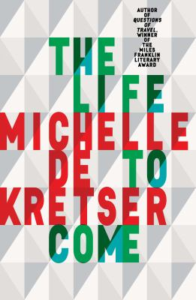
The Life to Come by Michelle De Kretser

Synopsis
Set in Sydney, Paris and Sri Lanka, The Life to Come is a mesmerising novel about the stories we tell and don’t tell ourselves as individuals, as societies and as nations.
It feels at once firmly classic and exhilaratingly contemporary. Pippa is a writer who longs for success. Celeste tries to convince herself that her feelings for her married lover are reciprocated. Ash makes strategic use of his childhood in Sri Lanka but blots out the memory of a tragedy from that time.
Driven by riveting stories and unforgettable characters, here is a dazzling meditation on intimacy, loneliness and our flawed perception of other people.

Discussion questions
- In an interview in the Sydney Morning Herald (30 September 2017), Michelle de Kretser explains: “The book is about imagining how life could be different, about what has not been achieved.” Discuss how you saw this reflected in the novel.
- The Life to Come is written in five parts — The Fictive Self, The Ashfield Tamil, The Museum of Romantic Life, Pippa Passes, Olly Faithful — which are all interconnected rather than follow on. Why do you think the author has chosen to write this way?
- Michelle de Krester talks about the importance of setting. Each part begins with placing the reader, discuss which setting stood out to you, and why.
- Consider the following quote (page 87): “These days, when Ash thought of Australia it seemed to belong less to his past than to a time to come, luminous and open-ended.” What are your thoughts on this?
- Consider the following quote (page 149): “Translation had taught Celeste that every book had an internal rhythm: energetic or languid, jittery or calm.” How would you describe the internal rhythm of The Life to Come?
- Consider the following quote (page 189): “Each audition piece was a problem he needed to solve: that was how he thought of music, as something strict and technical stripped of the fuzzy notions about self-expression that people brought to art.” Discuss.
- While there are many characters featured in the book, there is one who is woven through every part — Pippa. As the story progresses, we learn more about Pippa and see her from different perspectives. What was your view of Pippa? What did you like about her? What did you dislike? Did your view change as the novel progressed? As you read through each part of the novel, was there a particular character’s story that stood out to you? If so, why?

Discussion questions from https://www.allenandunwin.com/browse/book/Michelle-de-Kretser-Life-to-Come-9781760296568

