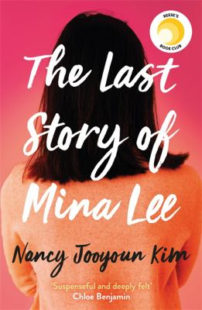
The Last story of Mina Lee by Nancy Jooyoun Kim

Synopsis
Margot Lee’s mother, Mina, isn’t returning her calls. It’s a mystery to twenty-six-year-old Margot, until she visits her childhood apartment in Koreatown, LA, and finds that her mother has suspiciously died.
The discovery sends Margot digging through the past, unraveling the tenuous invisible strings that held together her single mother’s life as a Korean War orphan and an undocumented immigrant, only to realize how little she truly knew about her mother.
Interwoven with Margot’s present-day search is Mina’s story of her first year in Los Angeles as she navigates the promises and perils of the American myth of reinvention. While she’s barely earning a living by stocking shelves at a Korean grocery store, the last thing Mina ever expects is to fall in love.
But that love story sets in motion a series of events that have consequences for years to come, leading up to the truth of what happened the night of her death.

Discussion questions
- How would you describe Mina and Margot, the two characters at the heart of this novel? What about their relationship—why it is so difficult? Why do mother and daughter find it so hard to understand one another?
- The police have ruled Mina's death accidental. Why does Margot doubt their conclusion? What, in her mind, makes it suspicious?
- As Margot begins her investigation into her mother's death, whom does she come to suspect? What about you?
- The Last Story of Mina Lee is about the perils and hardships of immigration. Why did Mina leave South Korea, and what were her hopes for a life in the United States? In what way did those dreams fall short?
- Do you believe that Mina's story typical of most, or at least many, newly arrived immigrants? Does the novel offer you insights into the rationale, dreams, and hardships of those who leave their countries and families behind to come to America?
- Talk about Margot's own journey as she explores her mother's life. How it change her? What does she come to understand about who her mother was—and, just as important, who she herself is?
- What do you see for Margot in the coming years? Do you believe she will see her grandmother?

Discussion questions from https://www.litlovers.com/reading-guides/13-reading-guides/fiction/11832-last-story-of-mina-lee-kim?showall=1

