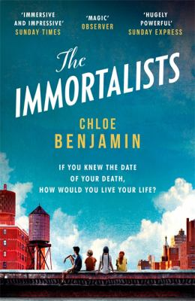
The Immortalists by Chloe Benjamin

Synopsis
If you knew the date of your death, how would you live your life?
It's 1969 in New York City's Lower East Side, and word has spread of the arrival of a mystical woman, a traveling psychic who claims to be able to tell anyone the day they will die. The Gold children --- four adolescents on the cusp of self-awareness --- sneak out to hear their fortunes.
Their prophecies inform their next five decades. Golden-boy Simon escapes to the West Coast, searching for love in '80s San Francisco; dreamy Klara becomes a Las Vegas magician, obsessed with blurring reality and fantasy; eldest son Daniel seeks security as an army doctor post-9/11, hoping to control fate; and bookish Varya throws herself into longevity research, where she tests the boundary between science and immortality.

Discussion questions
- The novel explores the degree to which we shape our own destinies. Do you believe that the siblings’ fate was preordained? Why or why not?
- The novel takes place in very different settings --- 1960s New York City, the San Francisco dance scene, glitzy Las Vegas hotels. In what ways do these locations affect the characters? Why do you think all four of the siblings moved away from New York City?
- The novel is narrated by the four siblings in separate sections. What was your reading experience when you switched sections? Did you identify more closely with certain siblings?
- At its heart, the novel is a family love story, exploring both past and future generations of the Gold family. In what ways does family history shape us? What kind of legacies do the four siblings leave behind?
- How do magic and reality blur in the novel? Were there any particular moments that seemed to defy logic? Why are certain characters drawn to magic and the unknowable more than others?
- Discuss the siblings’ significant others: Raj, Mira and Robert. How are their lives affected by the prophecy? How do romantic and familial relationships interact and contrast in the novel?
- At the end of the novel, Gertie tells Varya about the beauty and freedom in uncertainty, questioning why her children believed the fortune teller. Did you believe the fortune teller? What gives the fortune teller her power? What freedoms does uncertainty bring?
- What do you imagine happens to Varya after the book ’s ending? How have her views on longevity and death changed?
- Would you want to find out the date of your death? How would you live your life differently if you had this information?

Discussion questions from https://www.readinggroupguides.com/reviews/the-immortalists/guide

